**PROJECT REPORT (MAJOR PROJECT) ON**

**ADVANCED DEPARTMENT MANAGEMENT SYSTEM**

**Submitted in Partial Fulfillment of Requirement of Master of Computer Application**

**IN**



**CALCUTTA INSTITUTE OF TECHNOLOGY**

**BY**

**NAME : ARITRA DUTTA (Reg No.-** **211770571010011)**

**DEBRAJ MAITY (Reg No.-** **211770571010014)**

**SAYAN SAMANTA (Reg No.-** **211770571010030)**

**WRITTIK BHATTACHARYA (Reg No.-** **211770571010038)**

**UNDER THE SUPERVISION OF Mr. BIPLAB KANTI DAS**

**Assistant Professor**

**Department of Master of Computer Application Calcutta Institute of Technology**



MAULANA ABUL KALAM AZAD UNIVERSITY OF TECHNOLOGY, WEST BENGAL

**(Formerly known as West Bengal University of Technology)**

**CALCUTTA INSTITUTE OF TECHNOLOGY**

**ADVANCED DEPARTMENT MANAGEMENT SYSTEM**

**Major Project Report**



SUBMITTED BY :- **NAME : ARITRA DUTTA, DEBRAJ MAITY SAYAN SAMANTA,WRITTIK BHATTACHARYA**

**Under Guidance of :-**

**Mr. BIPLAB KANTI DAS**

**Asst. Professor, Department of MCA**

**Calcutta Institute of Technology**



#### CALCUTTA INSTITUTE OF TECHNOLOGY BANITABALA, ULUBERIA, HOWRAH-711316

MASTER OF COMPUTER APPLICATION

#### CERTIFICATE OF APPROVAL

THIS IS TO CERTIFY THAT DEBRAJ MAITY, ARITRA DUTTA, SAYAN SAMANTA, WRITTIK BHATTACHARYA HAVE COMPLETED THEIR MCA (MASTER OF COMPUTER APPLICATION) FINAL YEAR PROJECT ENTITLED “ADVANCED DEPARTMENT MANAGEMENT SYSTEM”. THEY HAVE DONE THEIR PROJECT WORK UNDER THE SUPERVISION OF THEIR GUIDE Mr. BIPLAB KANTI DAS, TEACHER-IN-CHARGE, MCA DEPARTMENT OF CALCUTTA INSTITUTE OF TECHNOLOGY, ULUBERIA. WE ARE SATISFIED WITH THEIR WORK, WHICH IS BEING PRESENTED FOR THE PARTIAL FULFILLMENT FOR THE DEGREE OF MASTER OF COMPUTER APPLICATION, MAULANA ABUL KALAM AZAD UNIVERSITY OF TECHNOLOGY, KOLKATA- 700064.

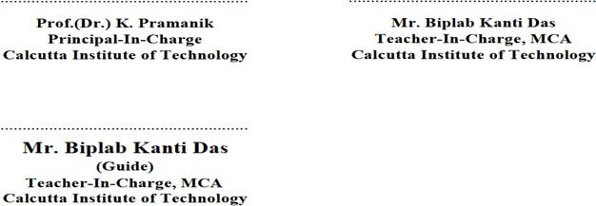

## ABSTRACT

Department Management System is essential for an Institution or to a college or to a university, which utilizes computer, also which reduces manpower. Main Objective of this study is an important step towards stream lining this effort is to develop a framework and identify necessary properties that a secure and trusted online department working system must satisfy to reduce discovery redundancy. Such a framework will allow us to evaluate as well as compare the merits of existing and future candidate in department.

System should support multi- user environment. System should be fully automated. System should provide concrete security features like creating users and assigning privileges to users of the system. System should be capable to keep track of all the detailed descriptions of the client and the whole details of services offered by the client.

# ACKNOWLEDGEMENT

Success of any project depends largely on the encouragement and guidelines of many others. We take this sincere opportunity to express our gratitude to the people who have helped and guided us throughout the process to successfully complete this project work. We would like to show our greatest appreciation and gratefulness to **Mr. Biplab Kanti Das,** Assistant Professor in the Master of Computer Application department at CALCUTTA INSTITUTE OF TECHNOLOGY. We always feel motivated and encouraged every time by his valuable advice and constant inspiration; without his encouragement and guidance, this project would not have materialized. We want to thank all our teachers for their encouragement and cooperation in carrying out this project work. The guidance and support received from all the members who contribute to this project us revisal for the success of this project.

**Aritra Dutta Debraj Maity**

**Department:**

**Master of Computer Application Calcutta Institute of Technology Uluberia-711316**

**Sayan Samanta Writtik Bhattacharya**

# INDEX

SL.No. CONTENT PAGE NO

1. Introduction
   1. Objective
   2. Scope
2. Specific Requirements
   1. Usability
   2. Reliability
      1. Availability
      2. Accessibility
   3. Design Constraints
      1. Software Language Used
      2. Development Tools
3. System Analysis
   1. Feasibility Study
   2. Economic Study
4. Existing System
5. Proposed System
6. System Development Analysis
   1. Data Flow Diagram(DFD)
   2. Entity Relationship Diagram(ERD)
   3. Use case Diagram
7. Data Tables
8. Sample Screenshot
9. Coding
10. Limitation
11. Future Scope
12. Conclusion
13. Bibliography
14. ***INTRODUCTION-***

***OBEJCTIVE***

Management System is a very important part of any educational institute. Project defines the all management of department System. It performs all functions which require to any educational institute.

In our system there are three types of users. First one is Admin, second one is Teacher and third one is Student.

For admin, they can login via their username and password to their account, after they are able to create a new batch when a session will be started and they can add teachers’ data also. After batch creation admin have to generate the routine of newly created class and also can see the class routine. Admin can add subjects for each semester. Admin can also add classrooms. Admin can assign the theory subjects with respect to teachers as per the teacher’s specialty, and also can assign the practical subjects with respect to teachers as per the teacher’s specialty. Admin can assign classrooms for each semester where teachers will take the class

.From admin dashboard admin can upload general notice and special notice (for some particular student). Admin can check students’ feedback for any teacher. Admin can also check lesion plan which is given by teachers. Admin can see their profile details and also admin can change their login credential (password).

For teacher, they can login via their username and password to their account. After starting a new session teacher have to upload a lesion plan for each assigned subjects. Teacher can also see the class time table (routine). Teacher can check the allotted room where they can take the class. Teacher can upload class notes for each and every class which they have taken as per the class time table (routine). Also teacher can upload the class assignments.

Teacher can see the general notices which are uploaded by admin for students. Teacher can see their profile details and also teacher can change their login credential (password).

For student, they can login via their username and password to their account. Student can view general notice and special notice. Student can write feedback for any teacher of their department. Students can see the assignments which are given by the teachers. Students can check their class time table (routine) which is generated by admin. Students can see their class notes which are given by teacher. Students can also give their examination. Students can see their profile details and also students can change their login credential (password).

# SCOPE

* This work done is aimed at developing an Online Web-based “Advanced Department Management System” that is of importance to a specific department of a college.
* The system is a web-based application that can be accessed throughout the department of an organization. This system may be used for monitoring the overall activities as well as performance of the students.
* This work is being developed for an engineering to maintain and facilitate easy access to information. For this the users must be registered with the system after which they can access as well as modify data as per the permissions given to them.
* “Advanced Department Management System” is a web-based application that aims at providing information to all the levels of department in an organization. For a given student/teacher can access the system to either upload or download some information to/from the database.

## SPECIFIC REQUIREMENTS-

### USEABILITY

Software usability refers to the controlled element of user experience design that makes sure that users do not face problems when using a website's user interface or product. A designer has the ability to control user interface, usability, control accessibility and information architecture to match the uncontrolled elements such as user lifestyle, objectives and habits. What you need to know is that UX design usually makes use of the controlled elements of technology to fit the uncontrolled aspects.

### RELIABILITY

* + 1. ***Availability***

System availability is a maintenance metric used to measure the amount of time—as a percentage—that an asset can be used for production. It calculates the probability that a system won’t experience downtime when workers need to use it.

Availability refers to the probability that a system performs correctly at a specific time instance (not duration). Interruptions may occur before or after the time instance for which the system’s availability is calculated. The service must:

* Be operational
* Adequately satisfy the defined specifications at the time of its usage

Availability is measured at its steady state, accounting for potential downtime incidents that can (and will) render a service unavailable during its projected usage duration. For example, a 99.999% (Five- 9’s) availability refers to 5 minutes and 15 seconds of downtime per year.

### Accessibility

Accessibility is the right thing to do. Providing accessible sites is part of the law in some countries, which can open up some significant markets that otherwise would not be able to use your services or buy your products.

Building accessible sites benefits everyone:

* Semantic HTML, which improves accessibility, also improves SEO, making your site more findable.
* Caring about accessibility demonstrates good ethics and morals, which improves your public image.
* Other good practices that improve accessibility also make your site more usable by other groups, such as mobile phone users or those on low network speed. In fact, everyone can benefit from many such improvements.

## Design Constraints

#### Software Language Used

* + Java Development Kit(8)
  + JSP
  + Servlet
  + Apache Tomcat Web Server(7.0.34)
  + DATABASE MySQL

##### Development Tools

* + VS Code Editor

##### Hardware Requirement

* MINIMUM REQUIREMENT

RAM:-2 GB ROM:-256 GB

PROCESSOR:- DUAL CORE

## Existing System:

In the Existing System, there is no Smart Attendance System Concept in any Project like us. There are no Auto Routine Generate concepts. There is no Concept of Special Notice for some Particular Students.

## Proposed System:

In our proposal, there are three types of users: Admin, Teacher, and Student.

Admin can register the students and teacher into the system, Admin can generate routine. From admin dashboard admin can upload general notice and special notice (for some particular student).Admin can upload the marks report of students from the admin dashboard and can give remarks for the students according to their marks. Admin can check students’ feedback for any teacher.

Teacher can upload assignments for student and take test of students and give them marks whatever they can secured.

Students can give test and submit assignments and check their marks and percentage of their attendance. Students can give the final exam with more security.

## SYSTEM DEVELOPMENT ANALYSIS

DATA FLOW DIAGRAM(DFD)

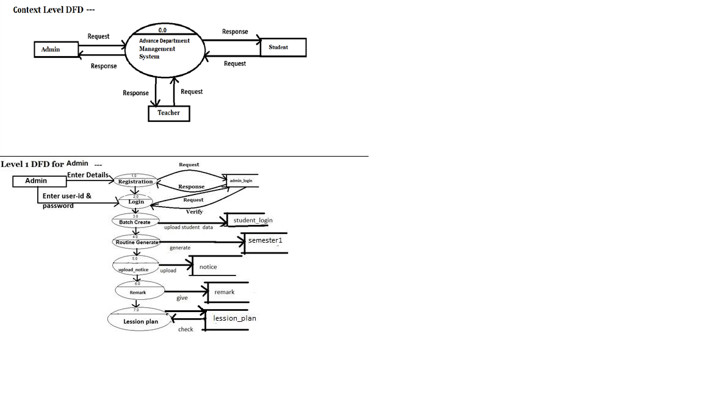

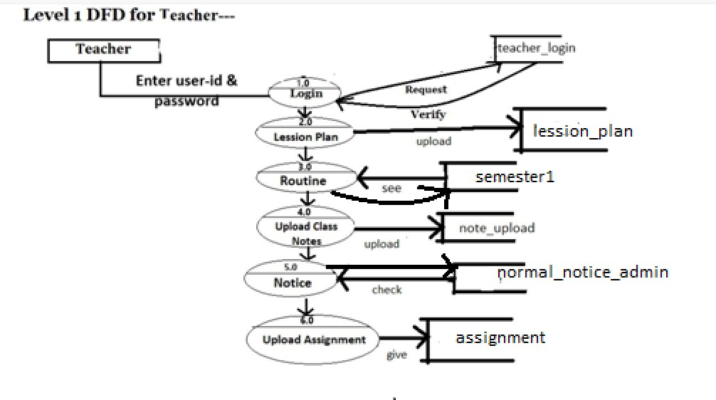

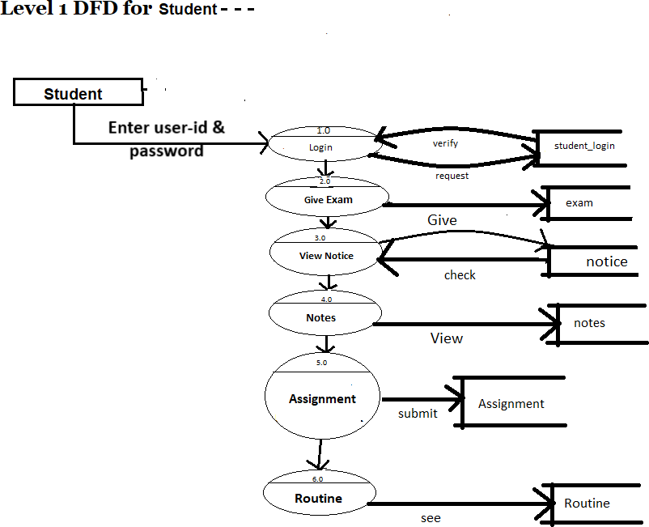

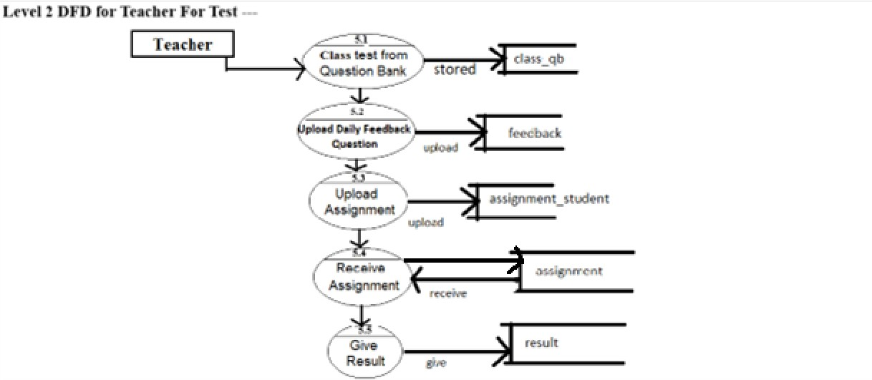

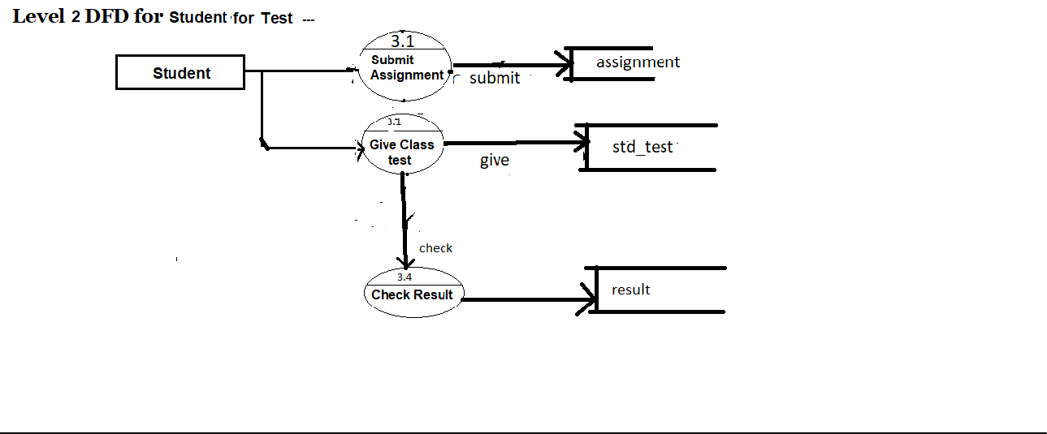

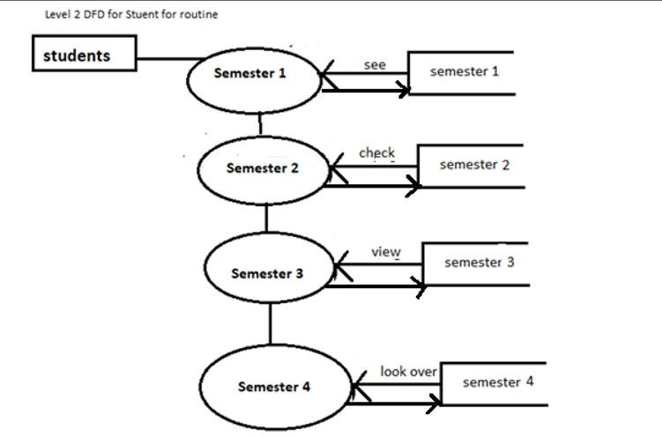

**ENTITYRELATIONSHIPDIAGRAM(ERD)**

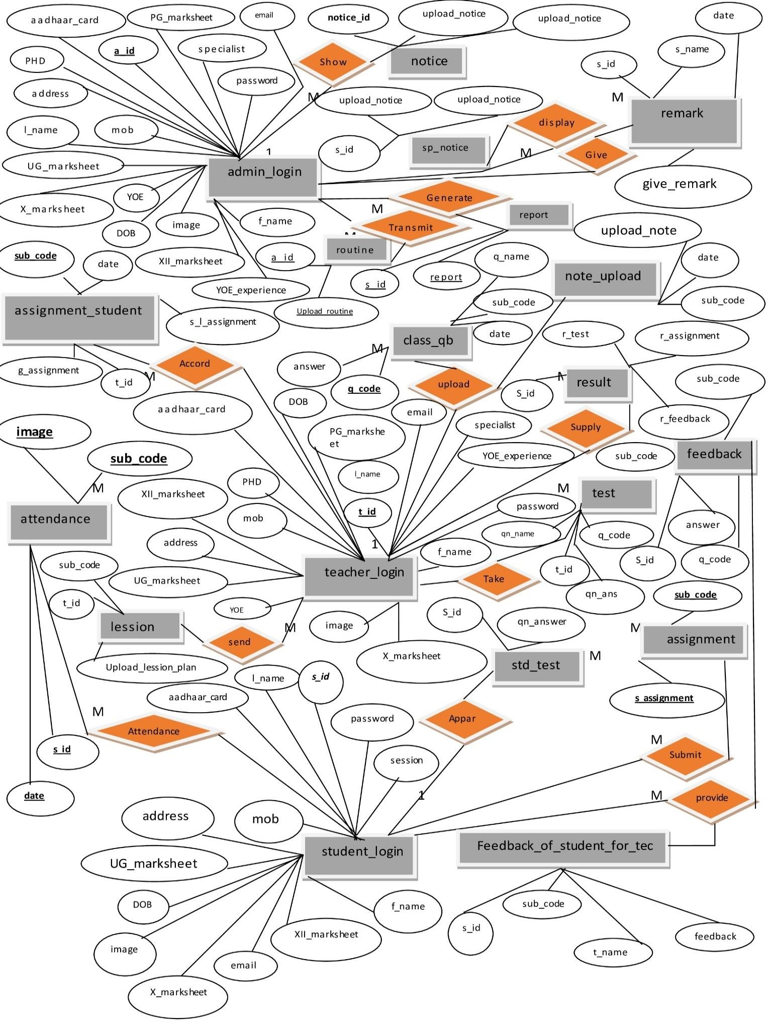

USECASEDIAGRAM

**TABLE STRUCTURE**

***STUDENTTABLES***

student_login-

|  |  |  |  |
| --- | --- | --- | --- |
| Fieldname | DataType | Size | Constrain |
| s_id | varchar | 10 | Primary key |
| password | varchar | 10 | not null |
| f_name | varchar | 30 | not null |
| l_name | varchar | 30 | not null |
| mob | varchar | 10 | not null |
| email | varchar | 30 | not null |
| address | varchar | 50 | not null |
| DOB | date | 8 | not null |
| X-marksheet | varchar | 200 | not null |
| XII-marksheet | varchar | 200 | not null |
| UG-marksheet | varchar | 200 | not null |
| aadhaar card | varchar | 12 | not null |
| Session | varchar | 20 | not null |
| image | varchar | 200 | not null |

assignment-

|  |  |  |  |
| --- | --- | --- | --- |
| Fieldname | Data Type | Size | Constrain |
| sub_code | varchar | 10 | Foreignkey |

|  |  |  |  |
| --- | --- | --- | --- |
| s_assignment | varchar | 200 | not null |
| s_id | varchar | 4 | Foreignkey |

feedback--

|  |  |  |  |
| --- | --- | --- | --- |
| Field name | Data Type | Size | Constrain |
| q_code | varchar | 5 | Foreignkey |
| sub_code | varchar | 3 | Foreignkey |
| s_id | varchar | 10 | Foreignkey |
| ans | varchar | 100 | not null |

std_test-

|  |  |  |  |
| --- | --- | --- | --- |
| Fieldname | Data Type | Size | Constrain |
| s_id | varchar | 4 | ForeignKey |
| qn_answer | varchar | 20 | not null |

feedback_of_student_for_tec-

|  |  |  |  |
| --- | --- | --- | --- |
| Fieldname | Data Type | Size | Constrain |
| s_id | varchar | 4 | Foreignkey |
| sub_code | varchar | 5 | not null |
| t_name | varchar | 20 | not null |
| feedback | varchar | 200 | not null |

***ADMINTABLES***

admin_login-

|  |  |  |  |
| --- | --- | --- | --- |
| Fieldname | Data Type | Size | Constrain |
| a_id | varchar | 10 | Primary key |
| password | varchar | 10 | not null |
| f_name | varchar | 30 | not null |
| l_name | varchar | 30 | not null |
| mob | varchar | 10 | not null |
| email | varchar | 30 | not null |
| address | varchar | 50 | not null |
| DOB | date | 8 | not null |
| X-marksheet | varchar | 200 | not null |
| XII-marksheet | varchar | 200 | not null |
| UG-marksheet | varchar | 200 | not null |
| PG-marksheet | varchar | 200 | not null |
| PHD | varchar | 200 | not null |
| aadhaar card | varchar | 12 | not null |
| specialist | varchar | 20 | not null |
| YOE | number | 2 | not null |
| YOE-certificate | varchar | 200 | not null |
| image | varchar | 200 | not null |

remark-

|  |  |  |  |
| --- | --- | --- | --- |
| Fieldname | Data Type | Size | Constrain |
| s_name | Varchar | 30 | not null |
| s_id | Varchar | 10 | Foreign Key |
| give_remark | Varchar | 100 | not null |
| date | date | 20 | not null |
|  |  |  |  |

notice-

|  |  |  |  |
| --- | --- | --- | --- |
|  | Data Type | Size | Constrain |
| notice_id | varchar | 10 | PrimaryKey |
| notice_topic | varchar | 200 | not null |
| upload_notice | varchar | 2000 | not null |

sp_notice-

|  |  |  |  |
| --- | --- | --- | --- |
| Fieldname | Data Type | Size | Constrain |
| s_id | varchar | 4 | Foreignkey |
| upload_notice | varchar | 200 | not null |
| topic_notice | varchar | 200 | not null |

routine-

|  |  |  |  |
| --- | --- | --- | --- |
| Fieldname | DataType | Size | Constrain |
| a_id | varchar | 4 | Foreignkey |
| upload_routine | varchar | 200 | not null |

report-

|  |  |  |  |
| --- | --- | --- | --- |
| Fieldname | DataType | Size | Constrain |
| s_id | varchar | 4 | Foreignkey |
| upload_report | varchar | 200 | not null |

***TEACHERTABLES—***

teacher_login-

|  |  |  |  |
| --- | --- | --- | --- |
| Fieldname | Data Type | Size | Constrain |
| t_id | varchar | 10 | Primarykey |
| password | varchar | 10 | not null |
| f_name | varchar | 30 | not null |
| l_name | varchar | 30 | not null |
| mob | varchar | 10 | not null |
| email | varchar | 30 | not null |
| address | varchar | 50 | not null |
| DOB | date | 8 | not null |
| X-marksheet | varchar | 200 | not null |
| XII-marksheet | varchar | 200 | not null |
| UG-marksheet | varchar | 200 | not null |
| PG-marksheet | varchar | 200 | notnull |
| PHD | varchar | 200 | not null |
| aadhaar card | varchar | 12 | not null |
| specialist | varchar | 20 | not null |
| YOE | number | 2 | not null |
| YOE-certificate | varchar | 200 | not null |
| image | varchar | 200 | not null |

assignment_student-

|  |  |  |  |
| --- | --- | --- | --- |
| Fieldname | Data Type | Size | Constrain |
| sub_code | varchar | 3 | Primary key |
| date | date | 8 | not null |
| g_assignment | varchar | 200 | not null |
| s_l_date | varchar | 8 | not null |
| t_id | varchar | 10 | Foreign  Key |

lession-

|  |  |  |  |
| --- | --- | --- | --- |
| Fieldname | DataType | Size | Constrain |
| t_id | varchar | 10 | Foreignkey |
| sub_code | varchar | 4 | Foreignkey |
| upload_lession_plan | varchar | 200 | not null |

class_qb-

|  |  |  |  |
| --- | --- | --- | --- |
| Fieldname | Data Type | Size | Constrain |
| q_code | varchar | 5 | PrimaryKey |
| q_name | varchar | 200 | not null |
| answer | varchar | 100 | not null |
| sub_code | varchar | 3 | Foreignkey |
| date | date | 8 | not null |

note_upload-

|  |  |  |  |
| --- | --- | --- | --- |
| Fieldname | Data Type | Size | Constrain |
| sub_code | varchar | 4 | Foreignkey |
| upload_notes | varchar | 200 | not null |
| date | date | 8 | not null |

result-

|  |  |  |  |
| --- | --- | --- | --- |
| Field name | Data Type | Size | Constrain |
| s_id | varchar | 4 | Foreignkey |
| r_test | varchar | 10 | not null |
| r_asn | varchar | 10 | not null |
| r_feedback | varchar | 10 | not null |

test-

|  |  |  |  |
| --- | --- | --- | --- |
| Field name | Data Type | Size | Constrain |
| q_code | varchar | 4 | Foreignkey |
| sub_code | varchar | 4 | Foreignkey |
| qn_name | varchar | 200 | not null |
| qn_ans | varchar | 200 | not null |
| t_id | varchar | 10 | Foreignkey |

9. SAMPLE SCREENSHOT

* 1. This is the front page of our website

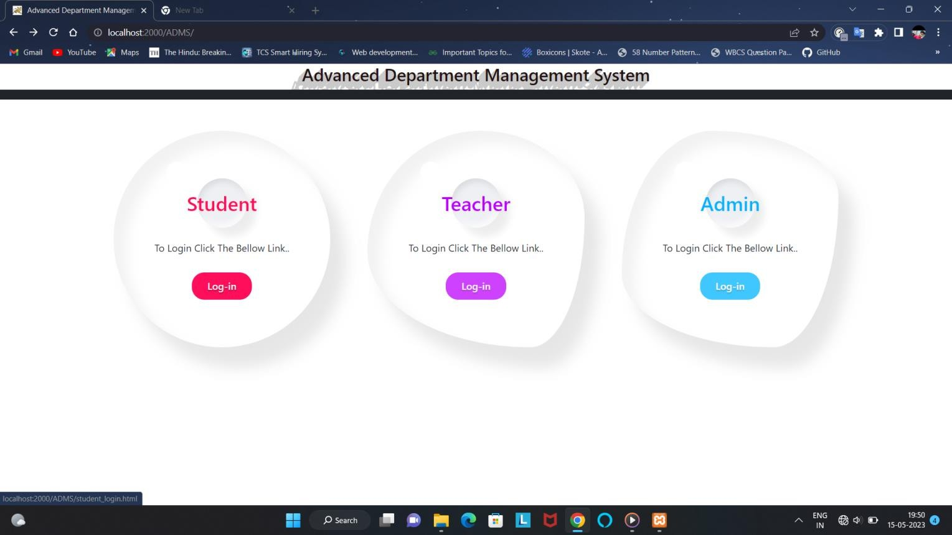

* 1. This is the student login form

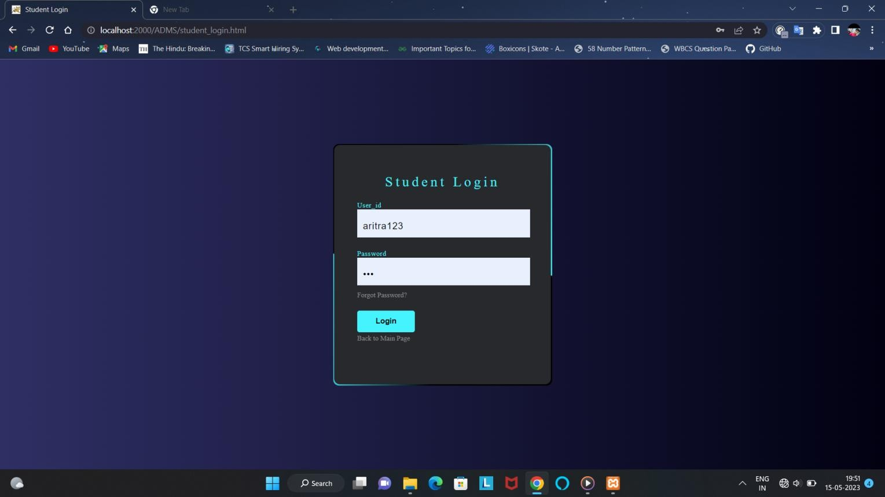

* 1. This is our student dashboard

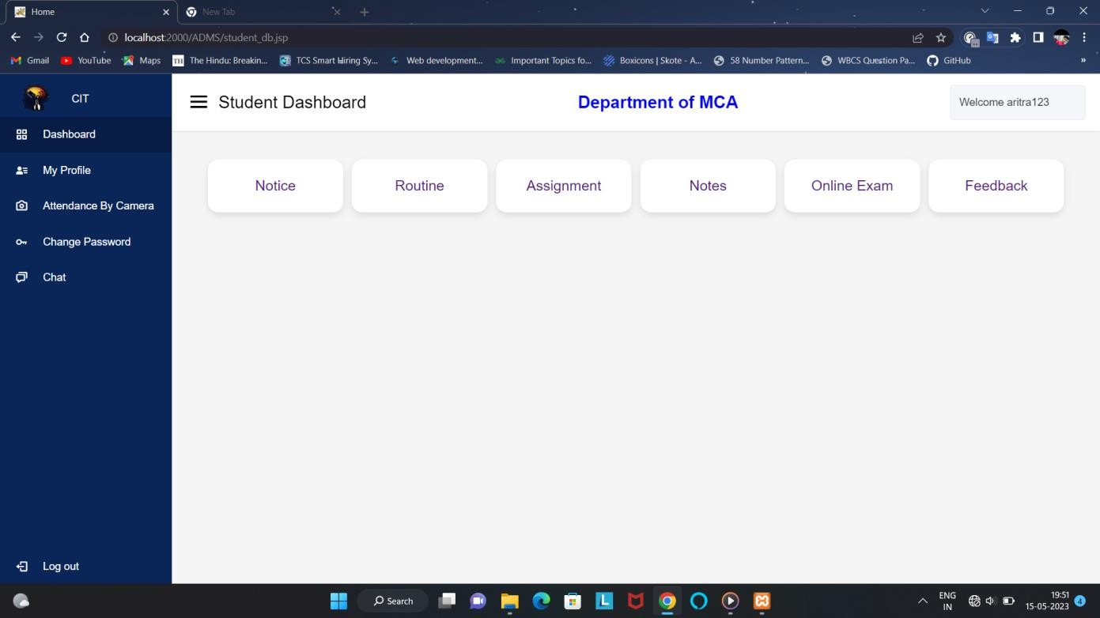

* 1. Display the student profile

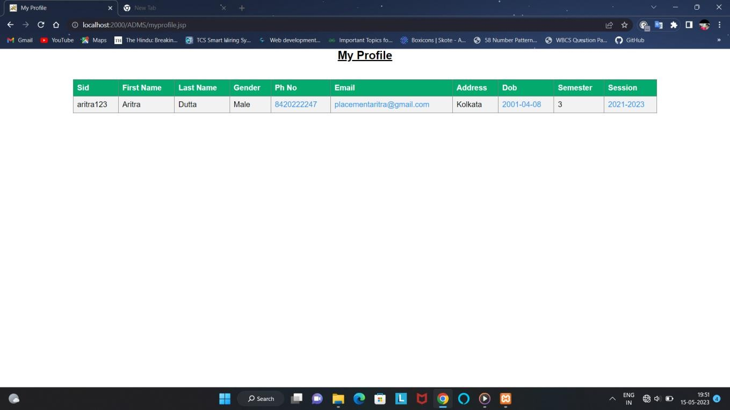

* 1. This is the change password form

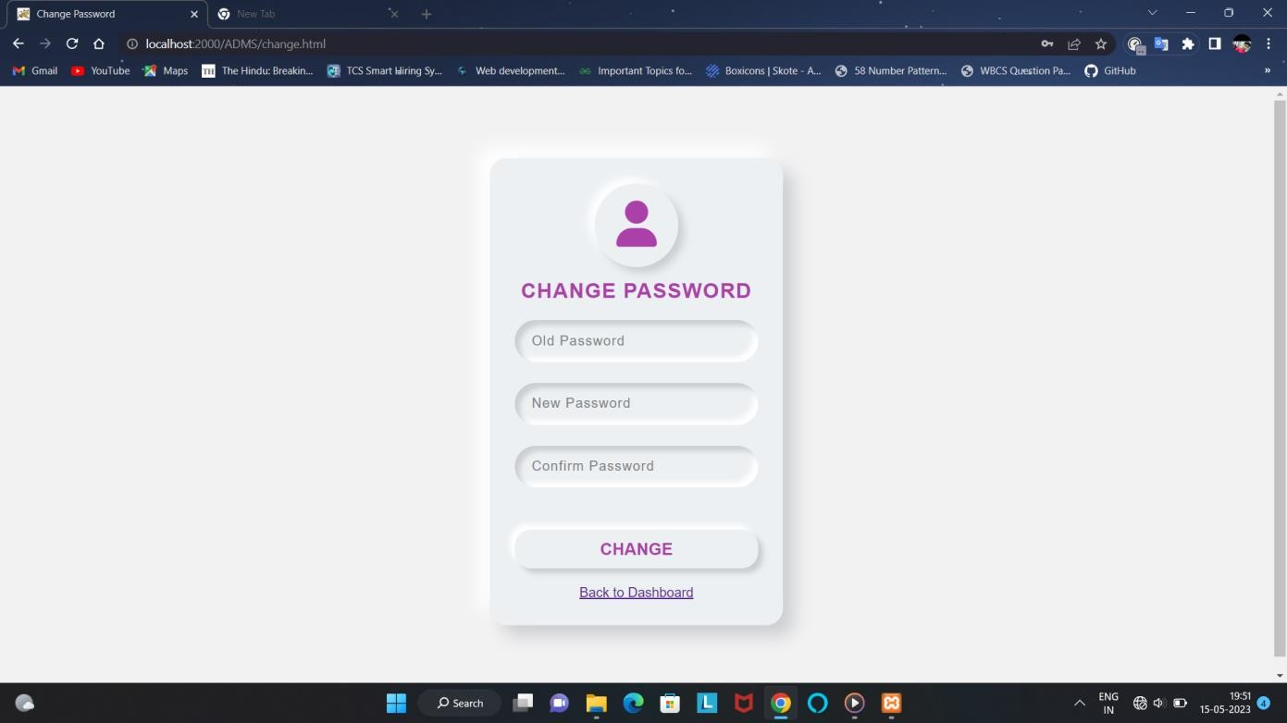

* 1. This is the notice options

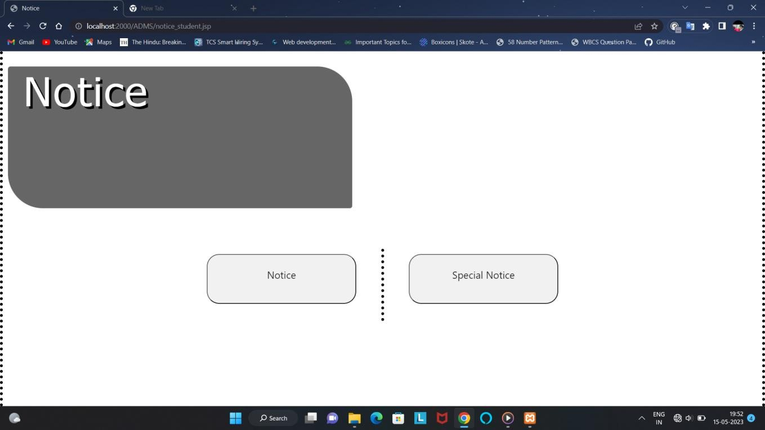

* 1. Displaying the general notice

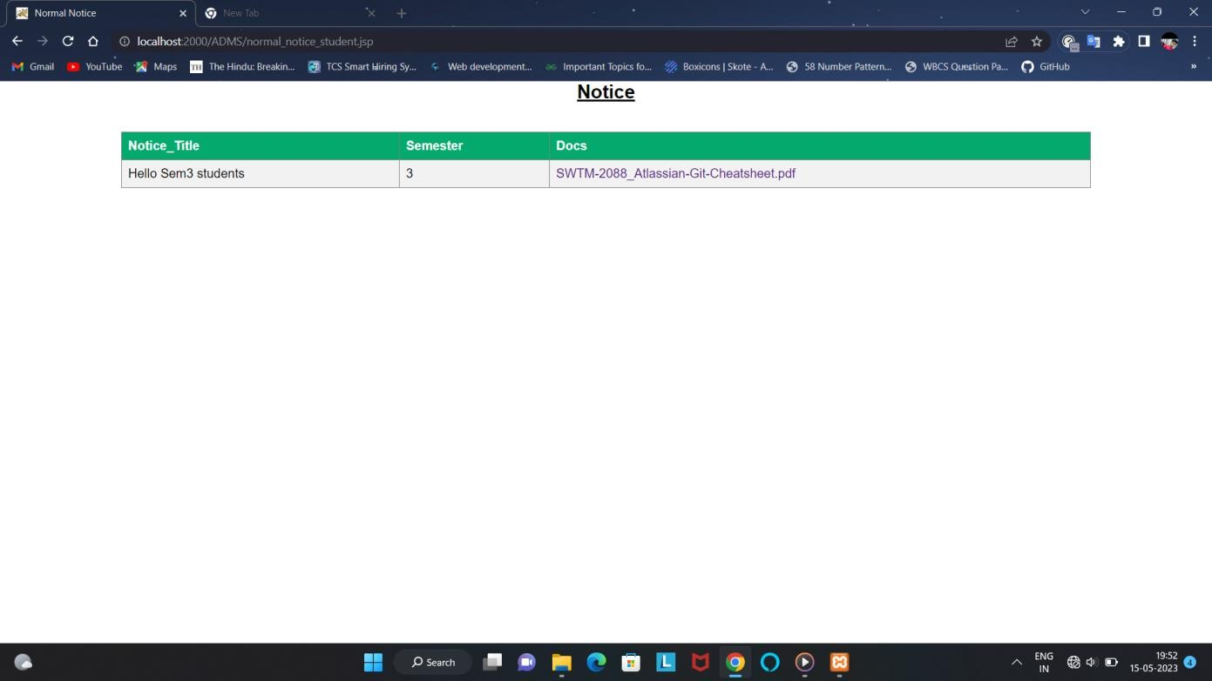

* 1. Displaying Special notice.

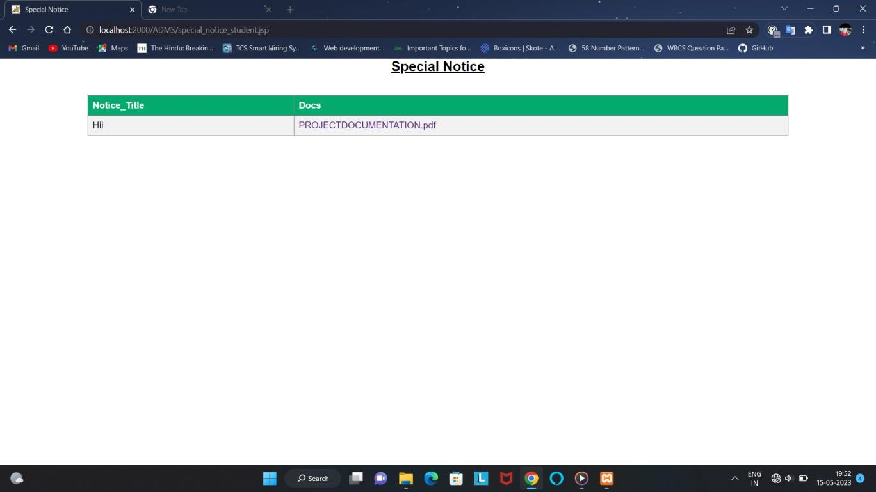

* 1. 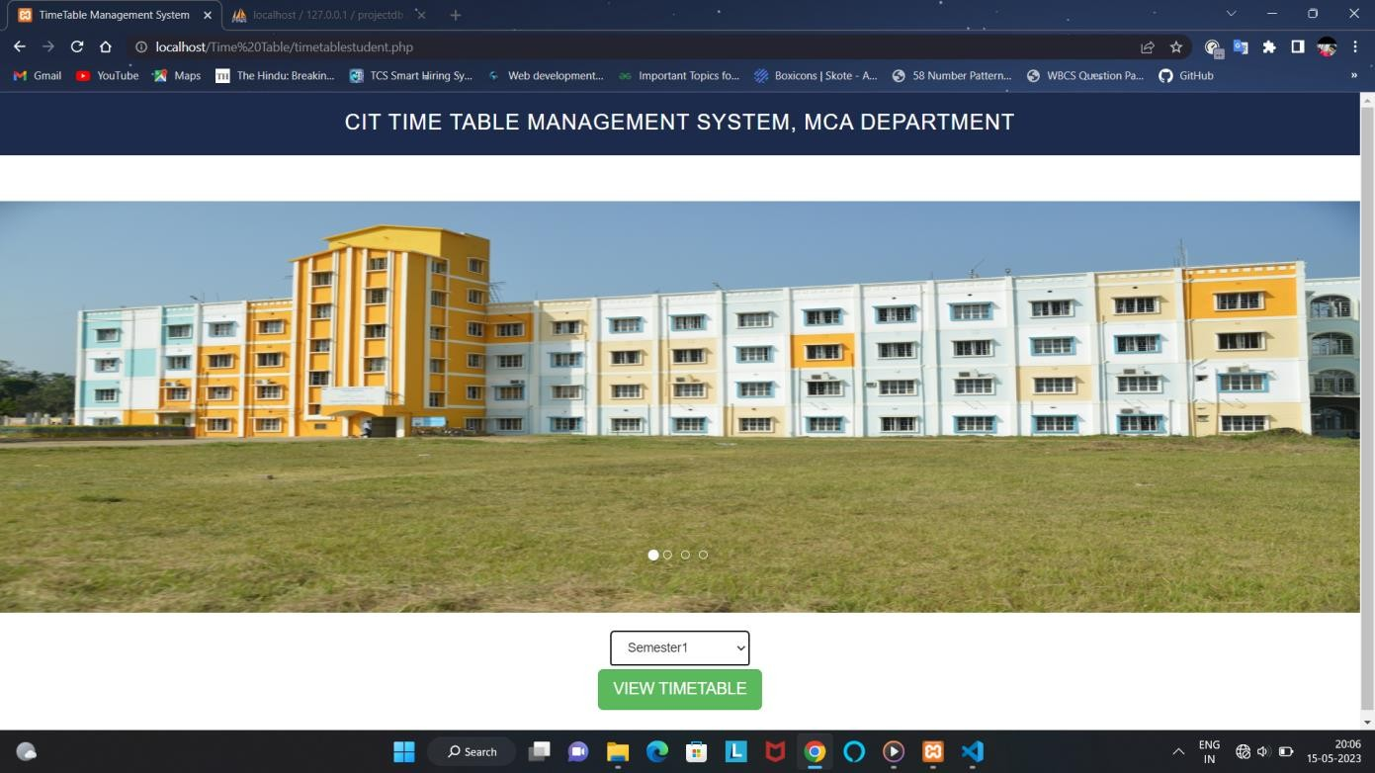First page of showing the class routine
  2. Here showing the class routine

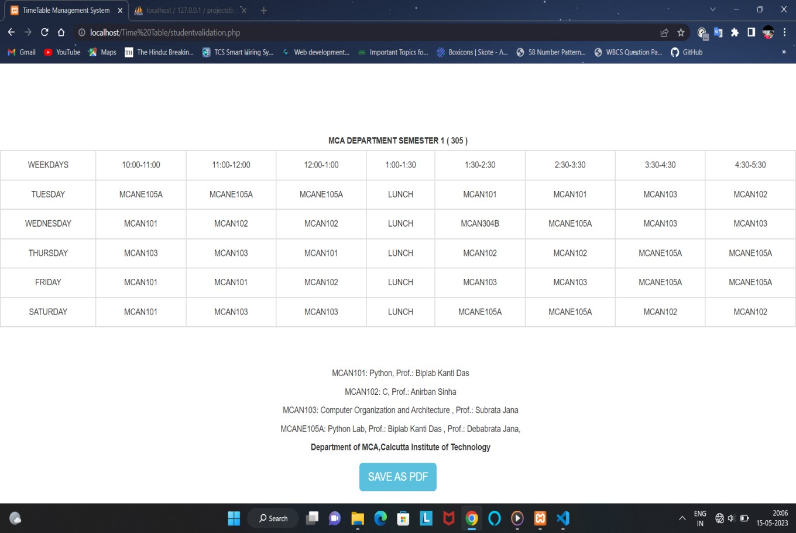

* 1. Student can show the uploaded assignment like that

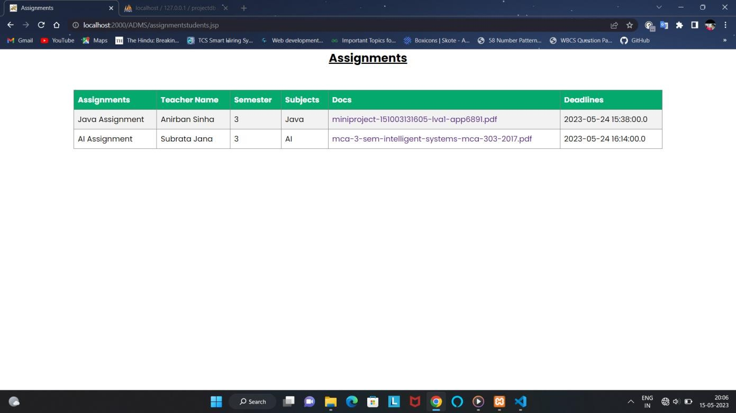

* 1. Student can show the uploaded class notes like that

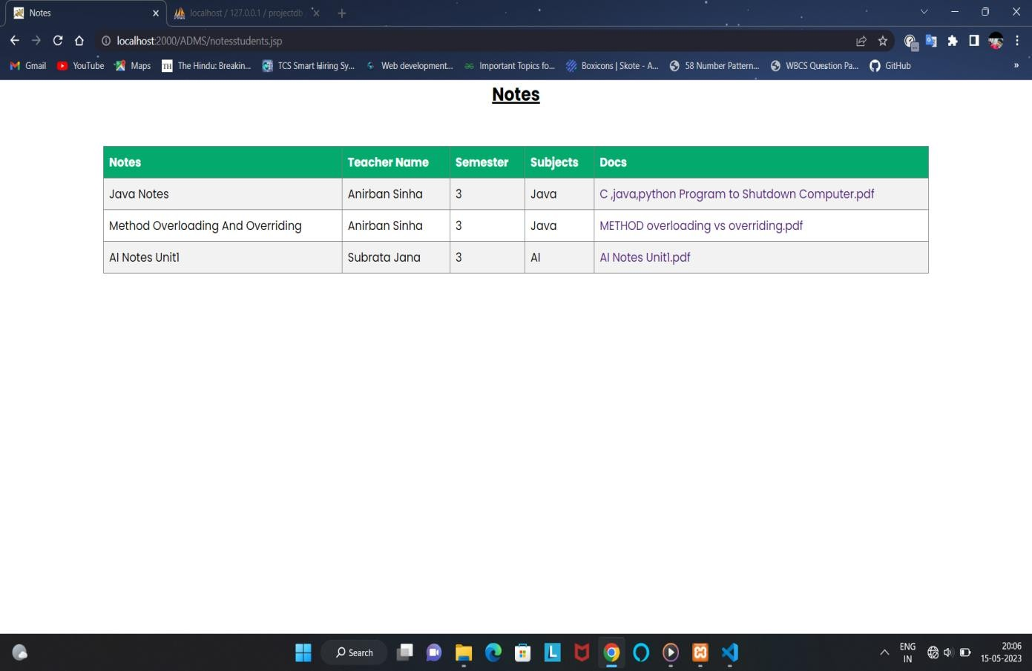

* 1. Exam page

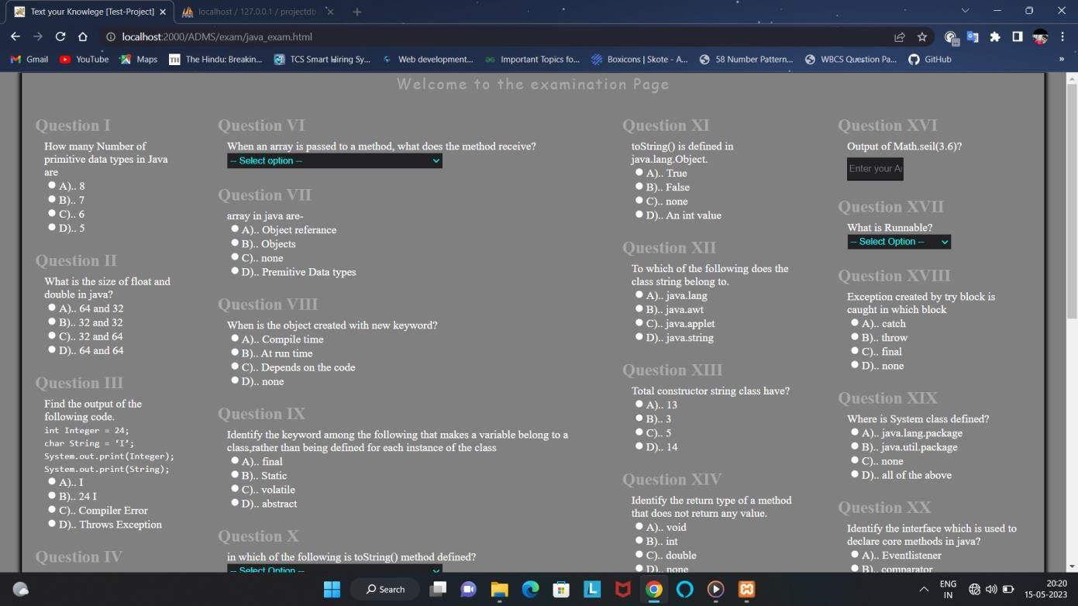

* 1. Student feedback form

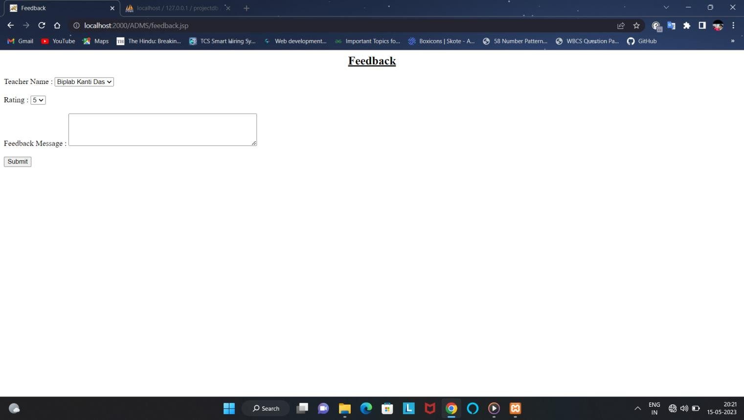

* 1. This is the teacher login form

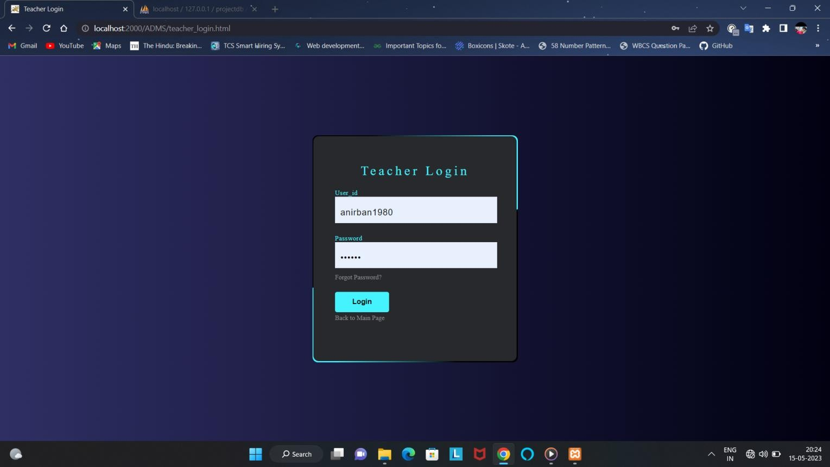

* 1. This is the Teacher dashboard page

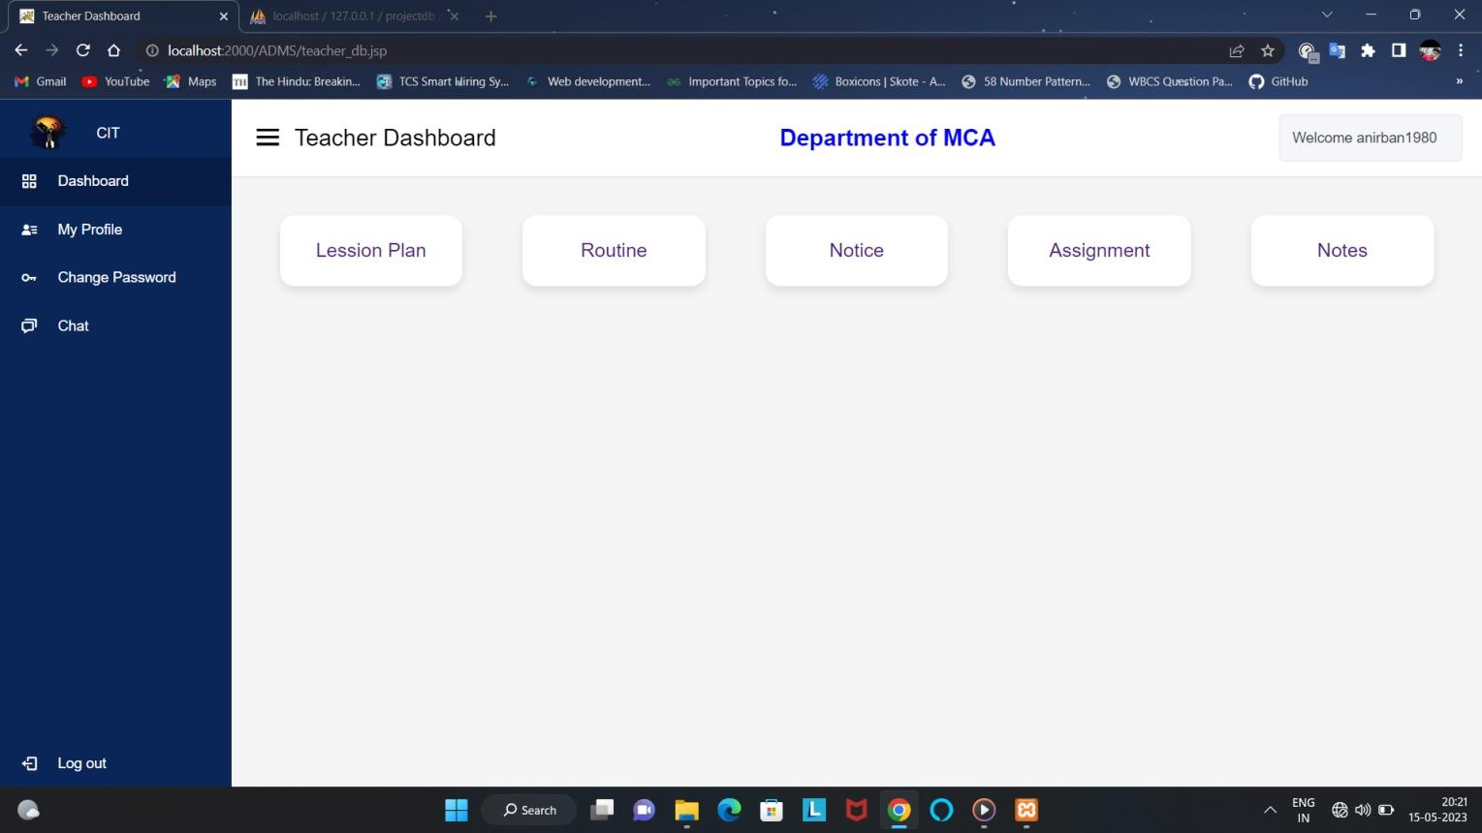

* 1. This is the teacher profile page

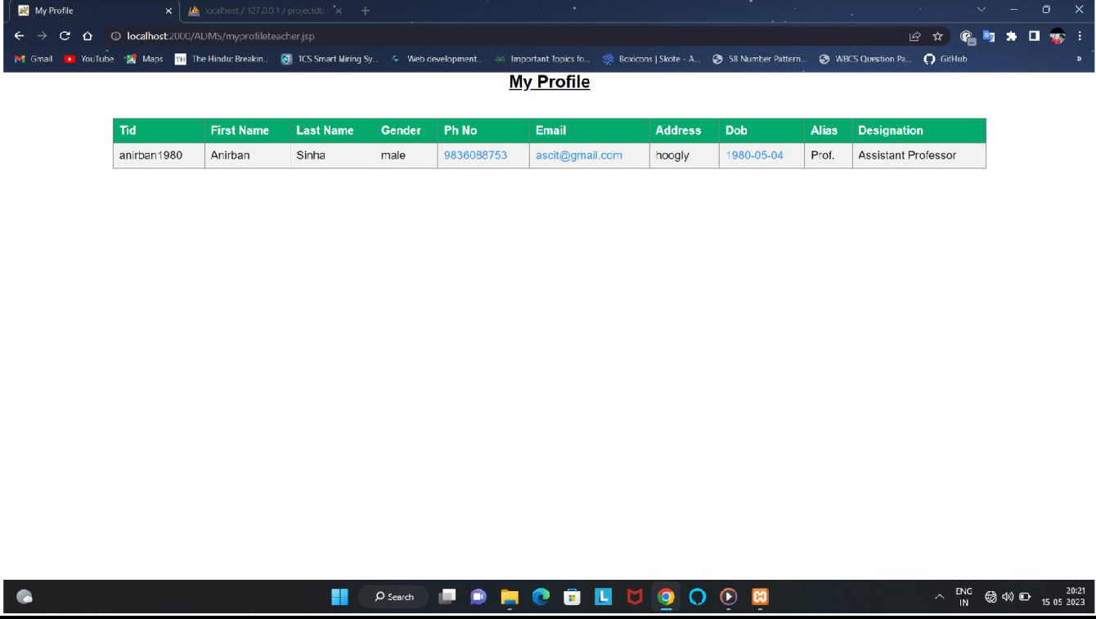

* 1. Teacher will update the lesion plan from here

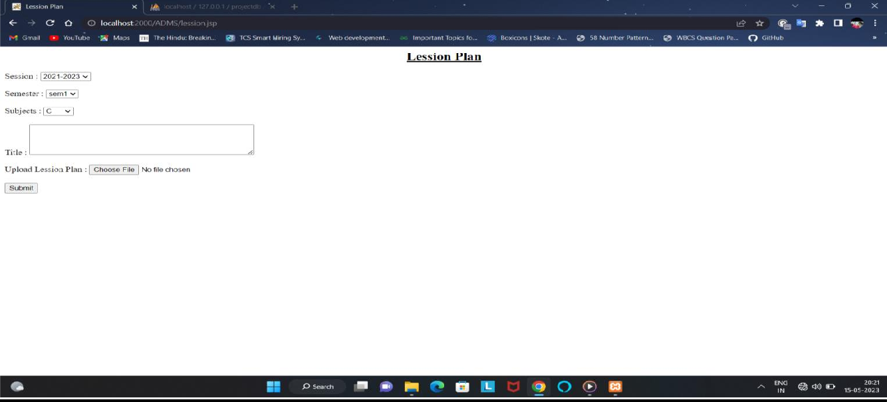

* 1. Teacher can show their class routine from here

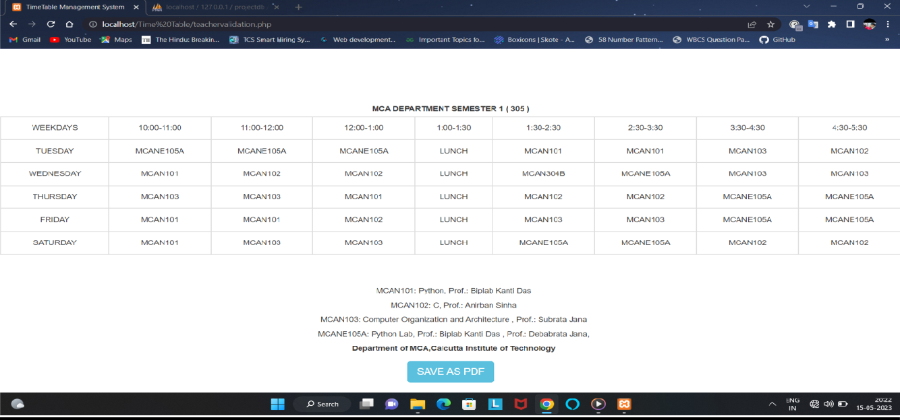

* 1. Teacher will see the notice

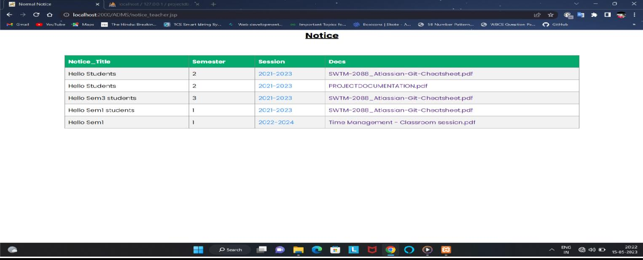

* 1. Teacher will upload the assignments

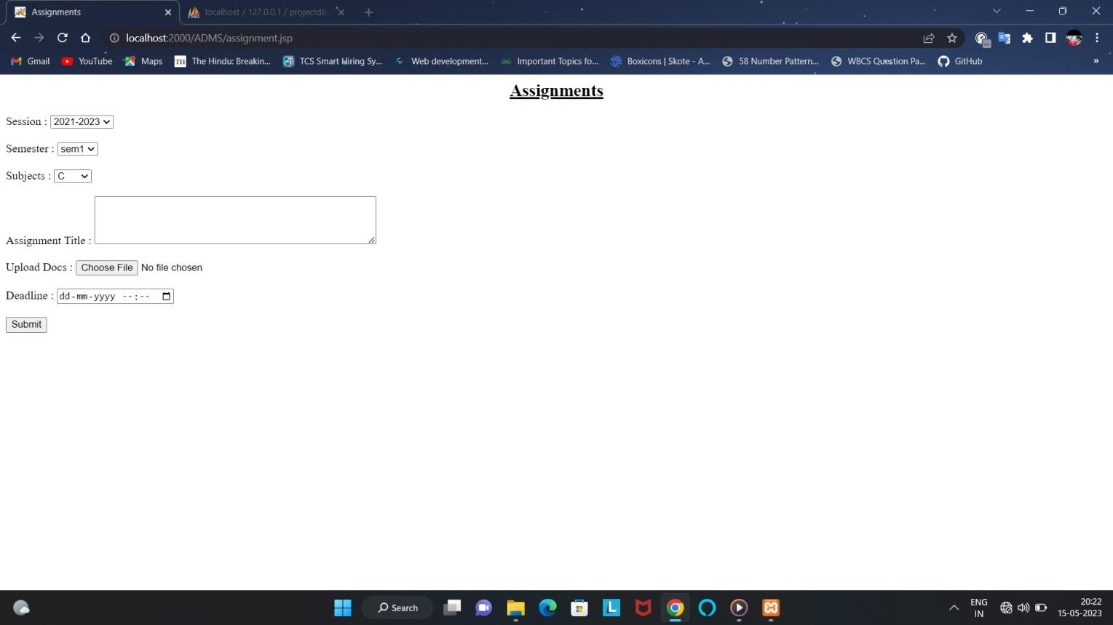

1. Teacher will upload the notes from here

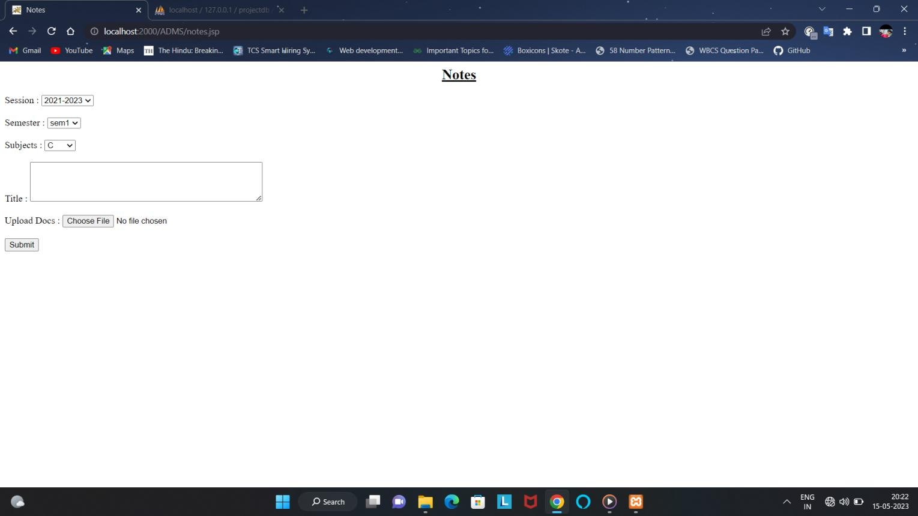

1. This is the admin login page

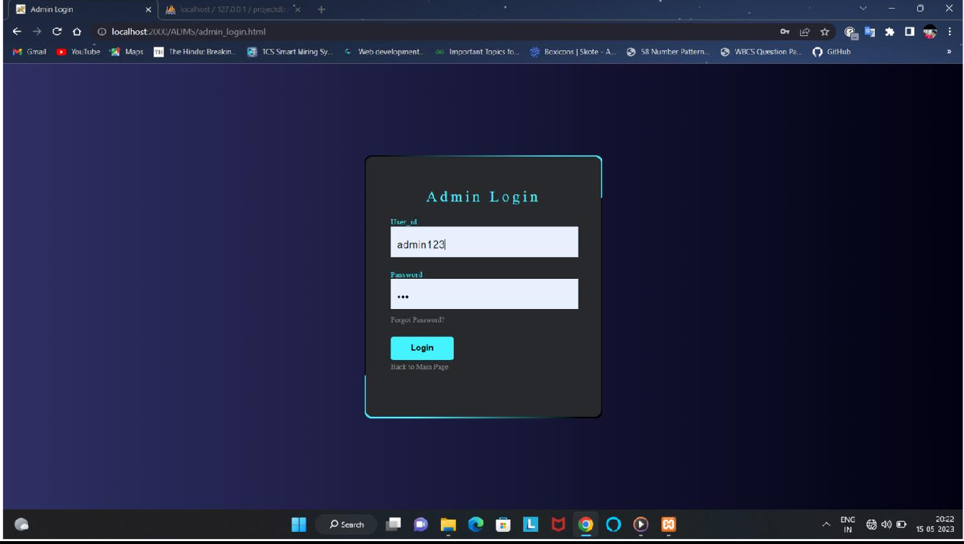

1. This is the admin dashboard

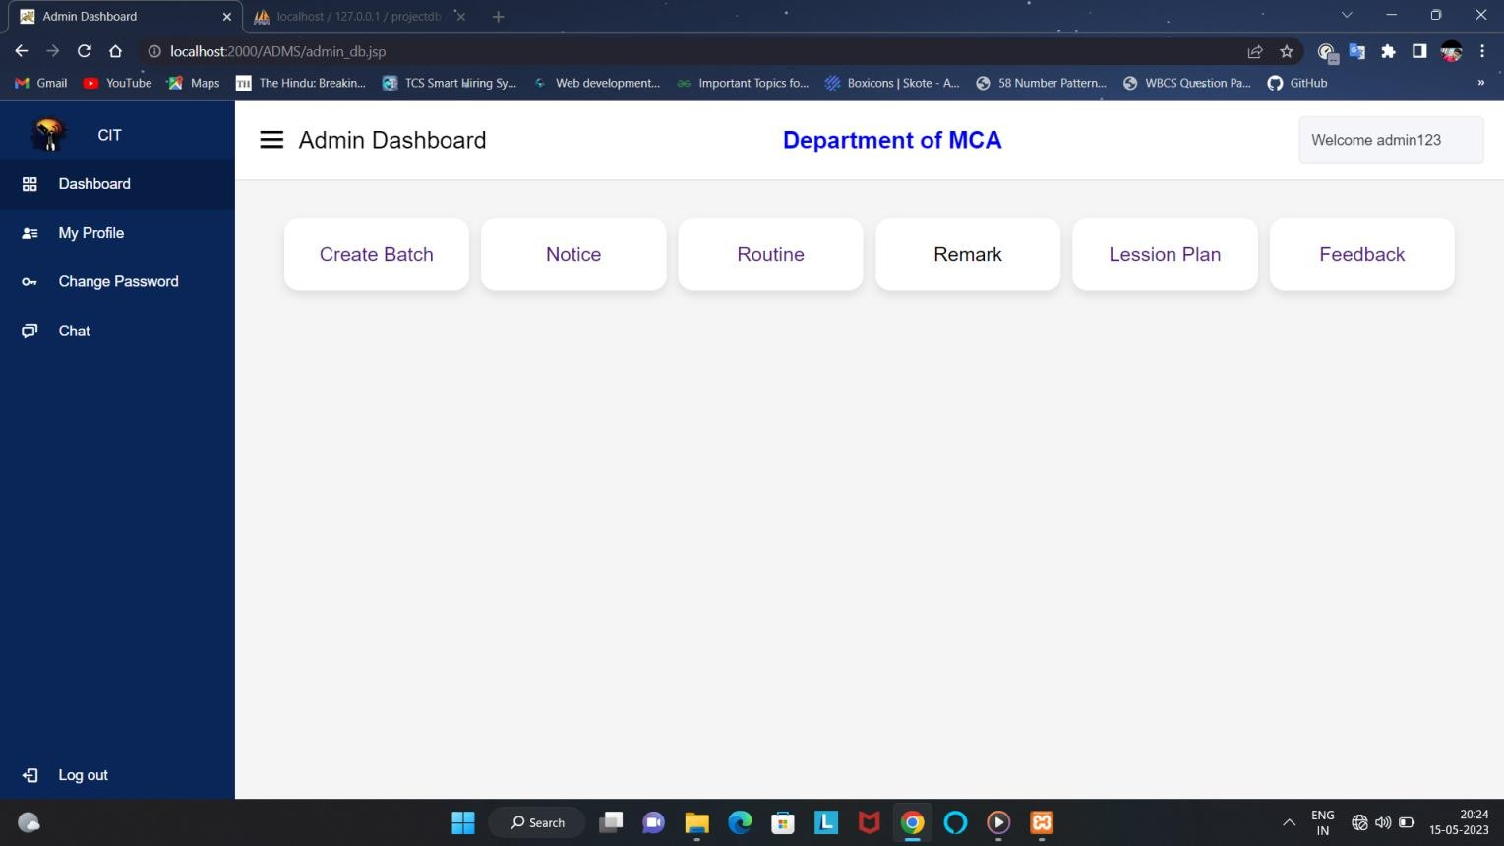

1. Admin profile page

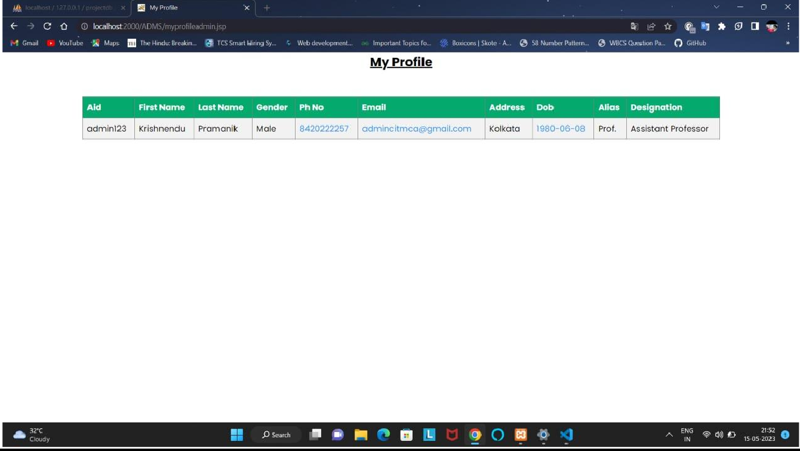

1. Here admin will choose the notice category

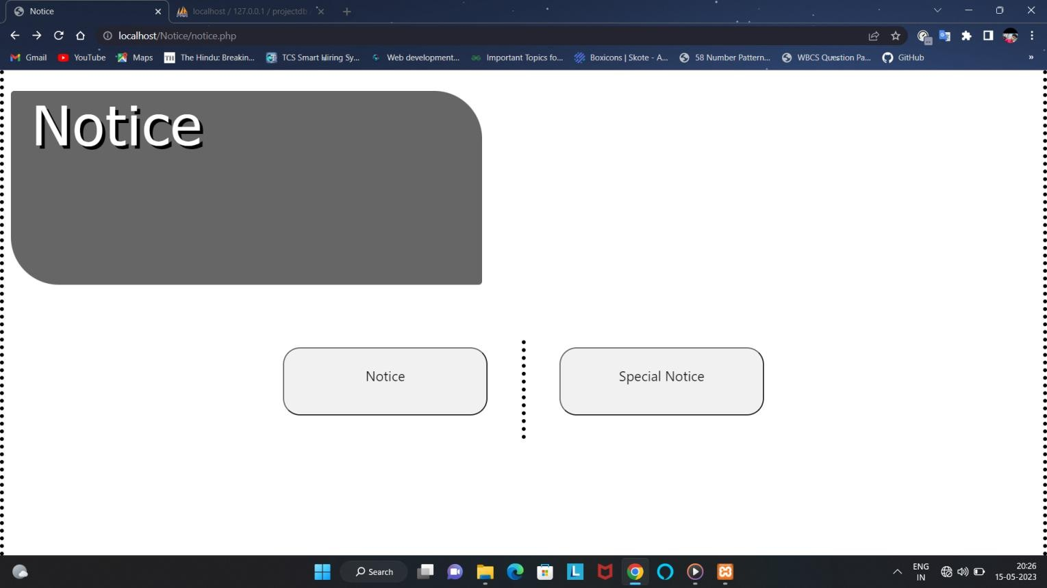

1. Here admin will upload the notice

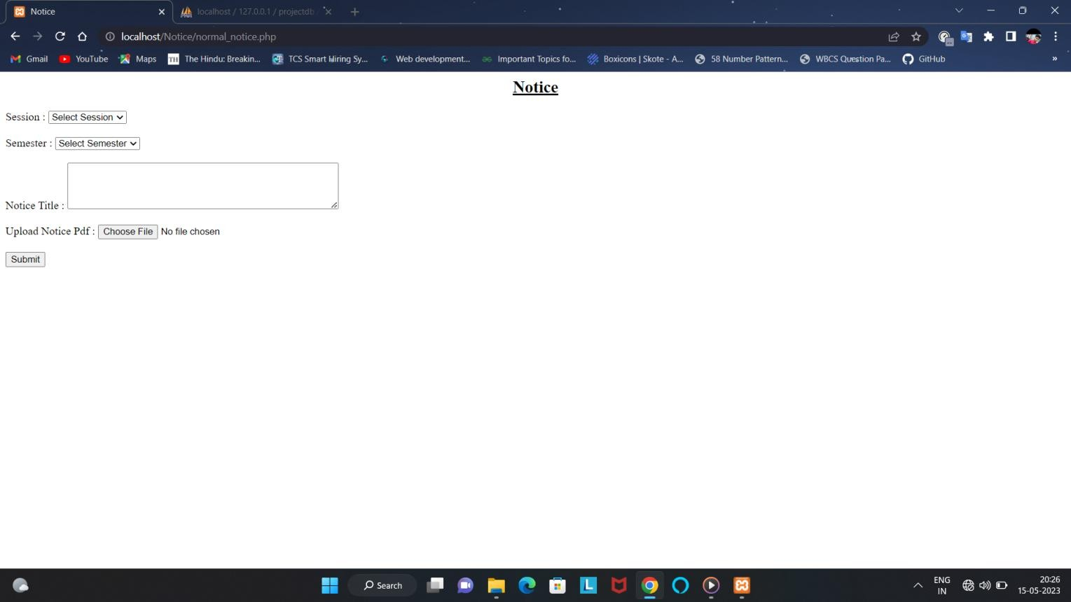

1. Here admin will upload the special notice

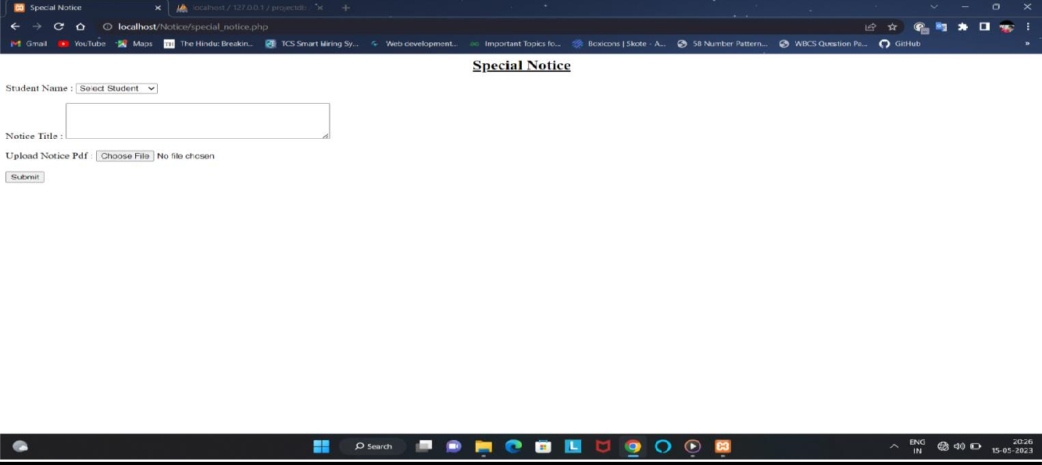

1. Here admin will see all teacher’s details

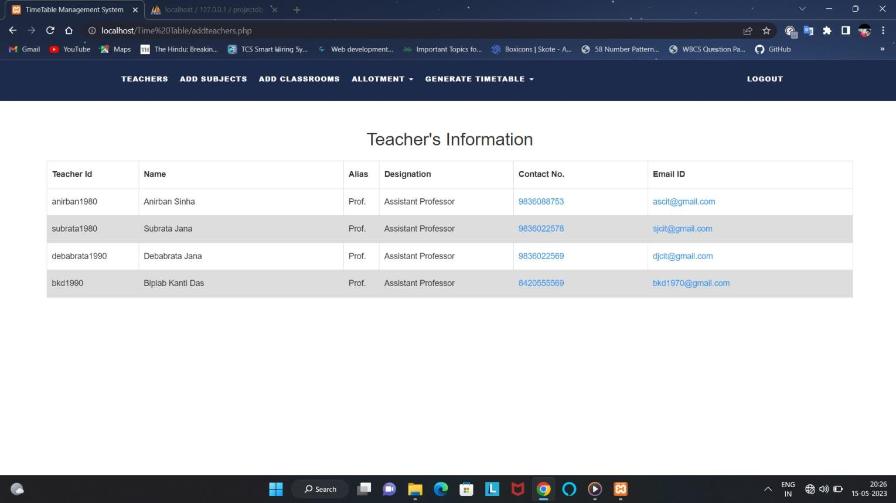

1. This is the add subject form

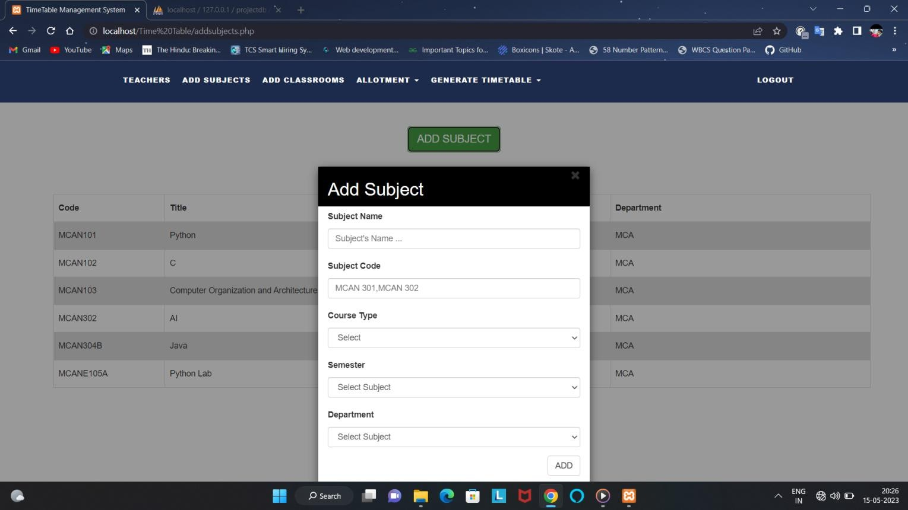

1. Here admin will allocate the class room

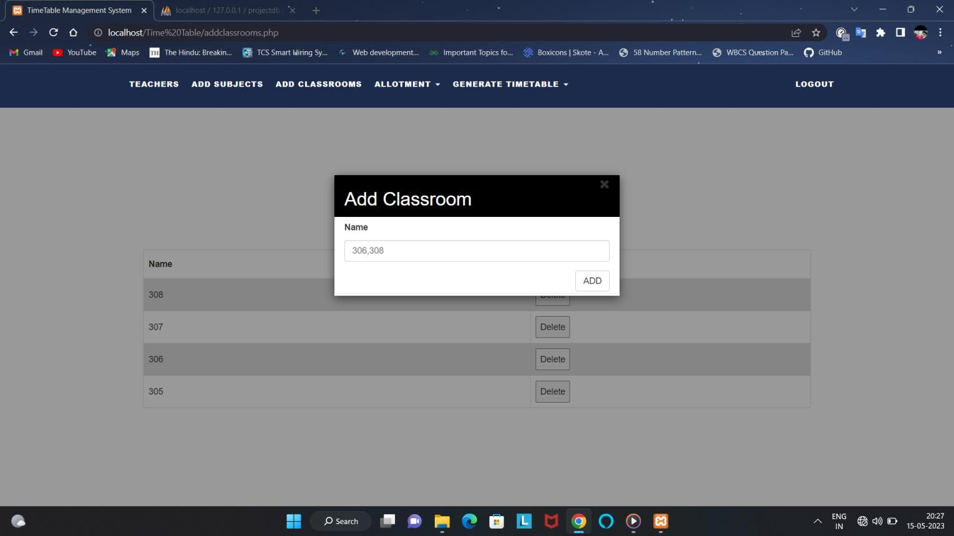

1. This is the subject allotting form

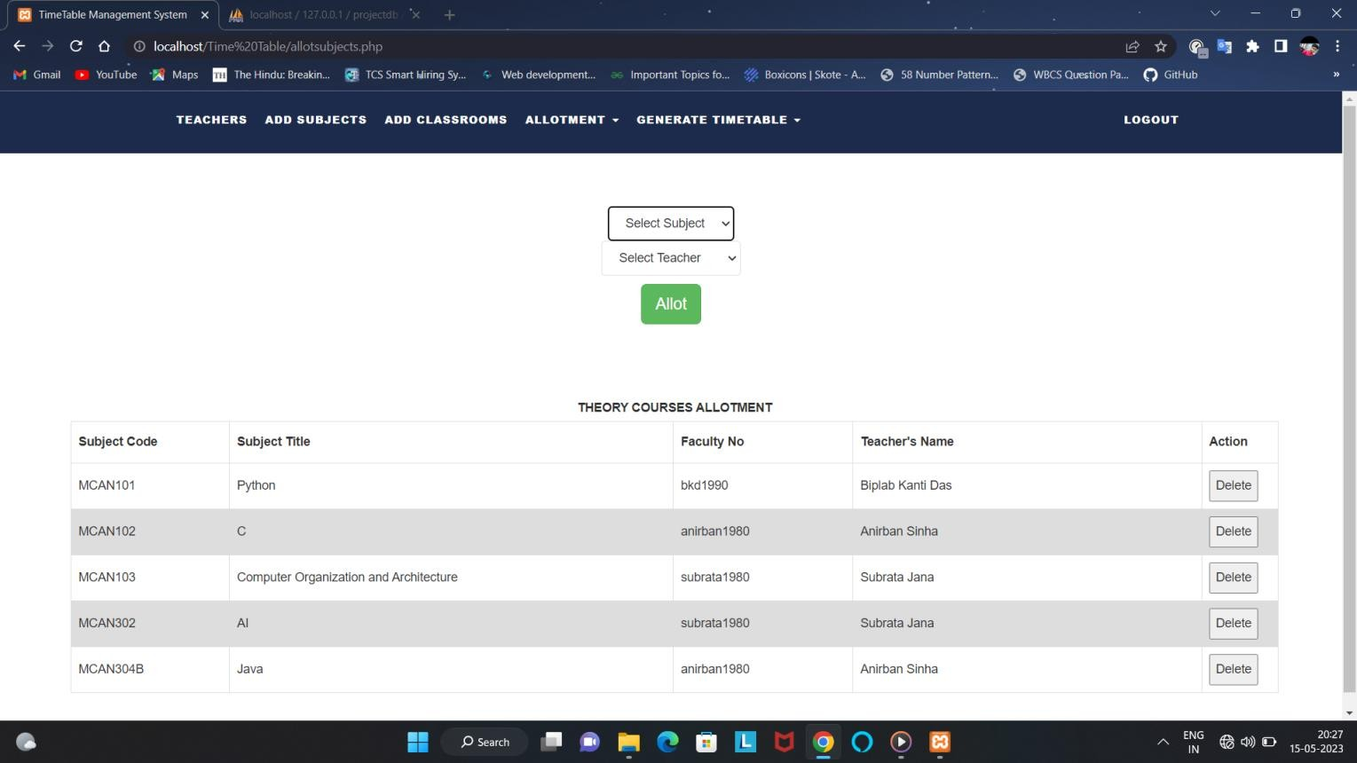

1. Here admin can allot the practical courses

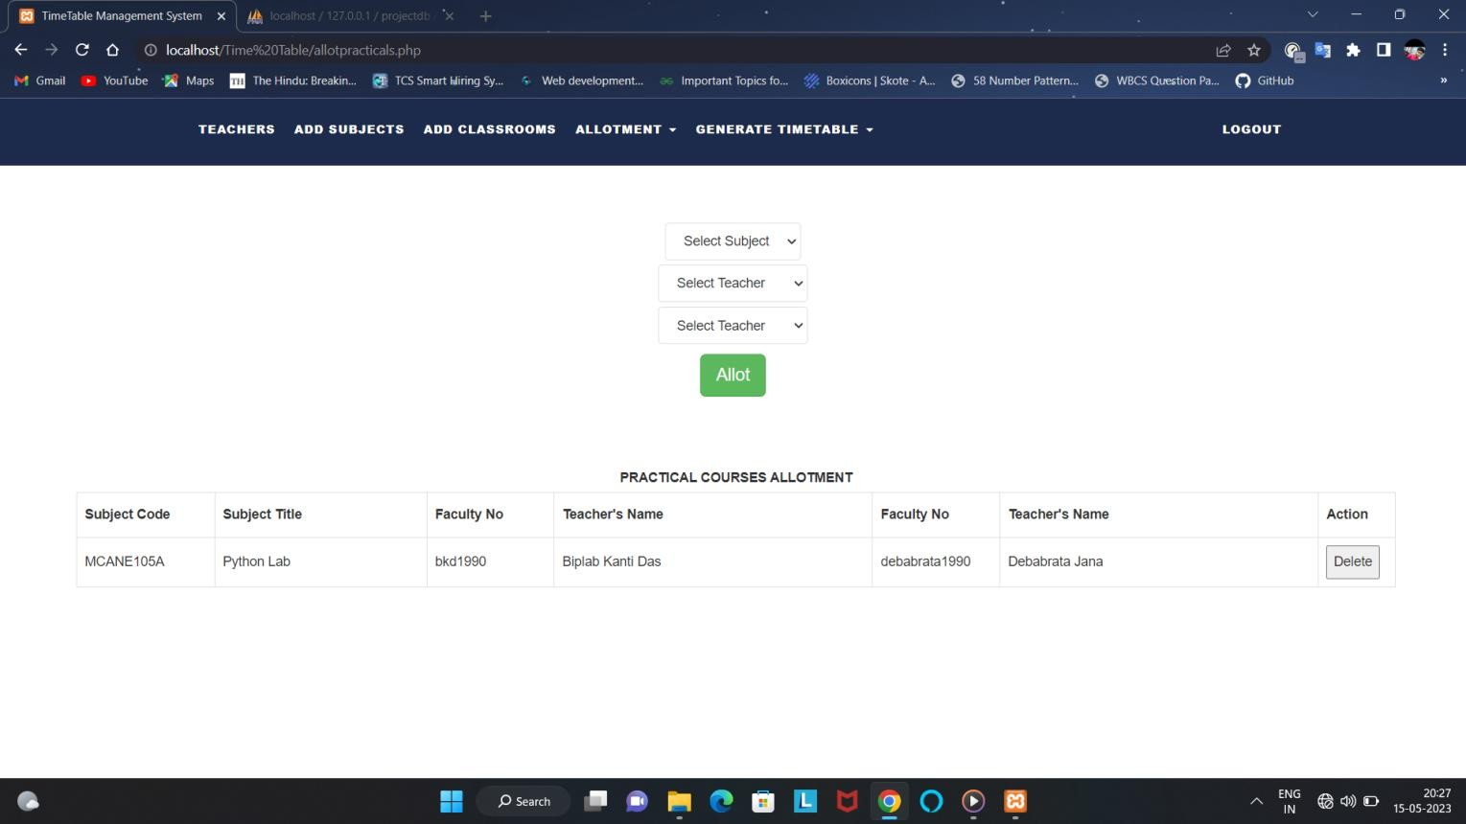

1. Admin can allot the class rooms

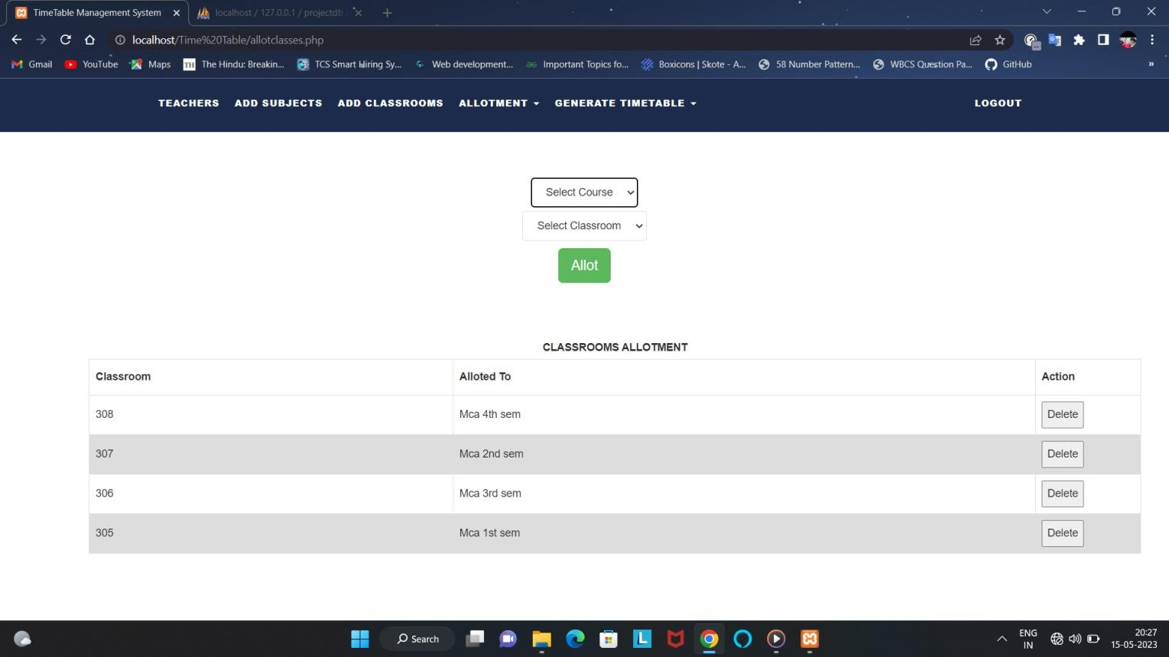

1. Here admin can generate the time table / routine

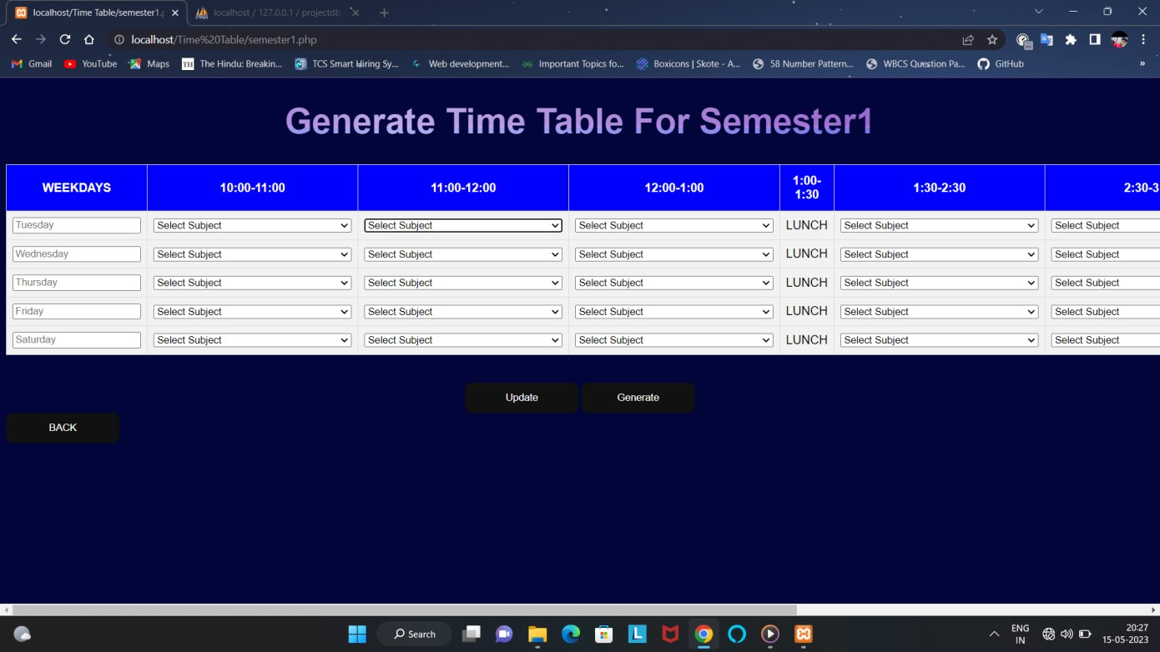

1. Admin can view the time table by selecting the semester

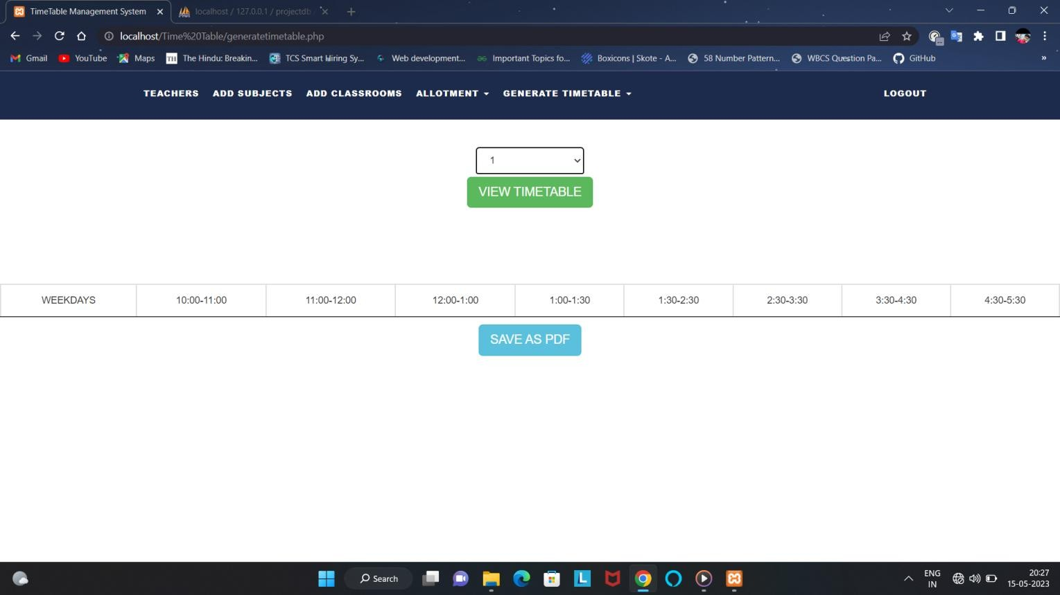

1. Displaying the generated routine

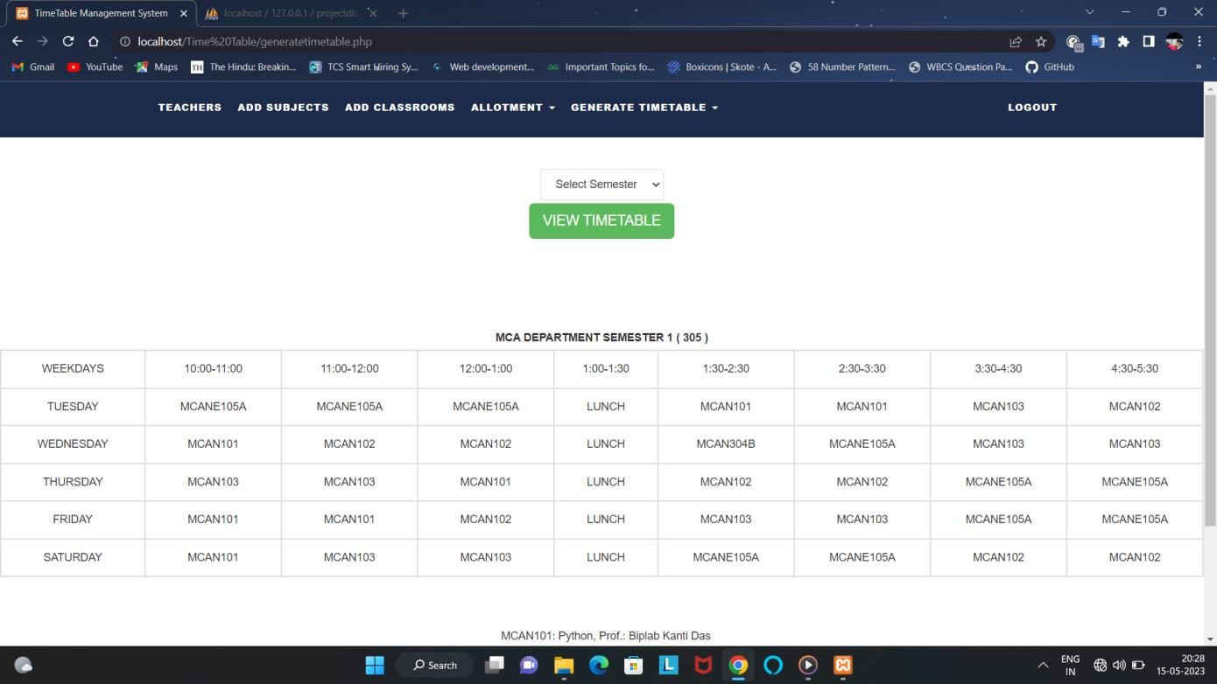

1. Admin can show the lesion plan

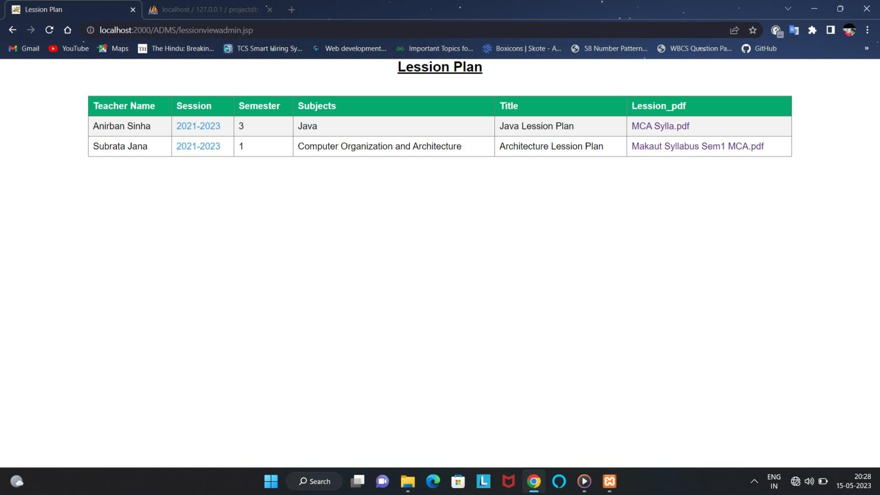

1. Admin can see the feedback of students’

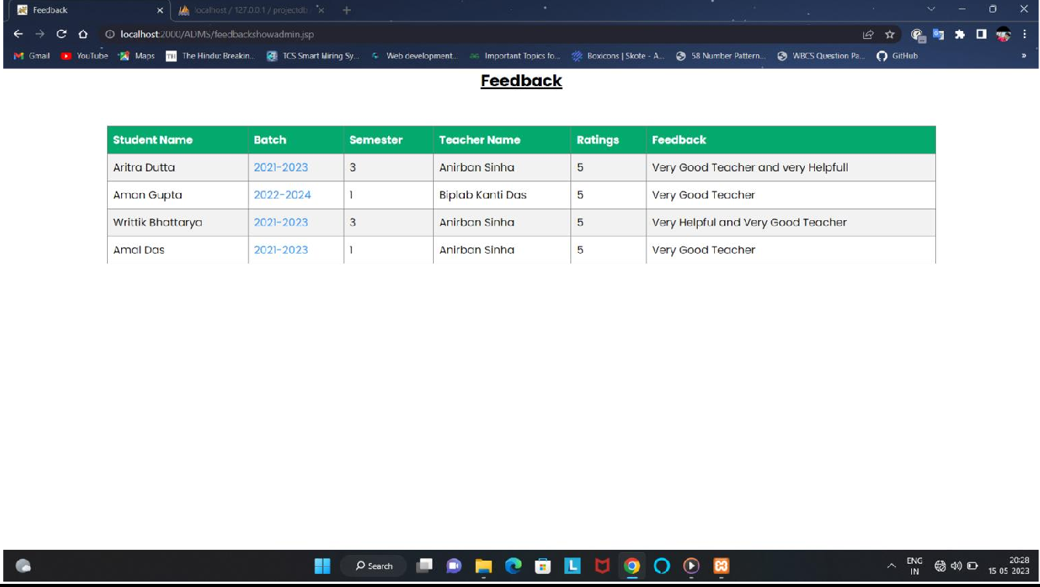

1. Code for student login page.

10. Coding

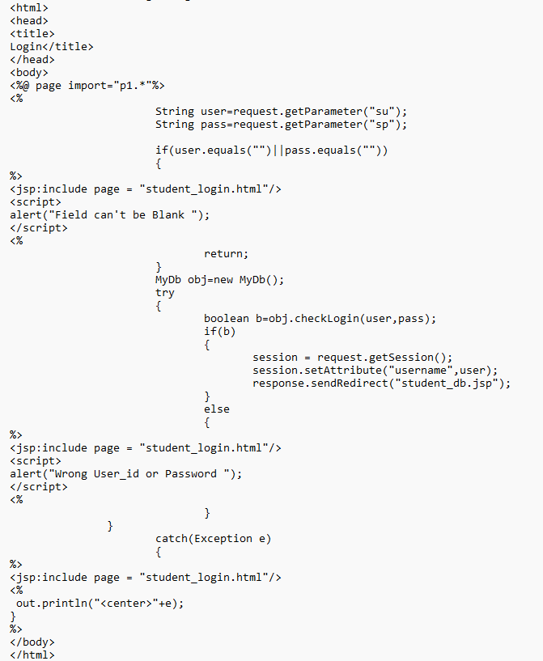

1. Code for Database (Student Login).

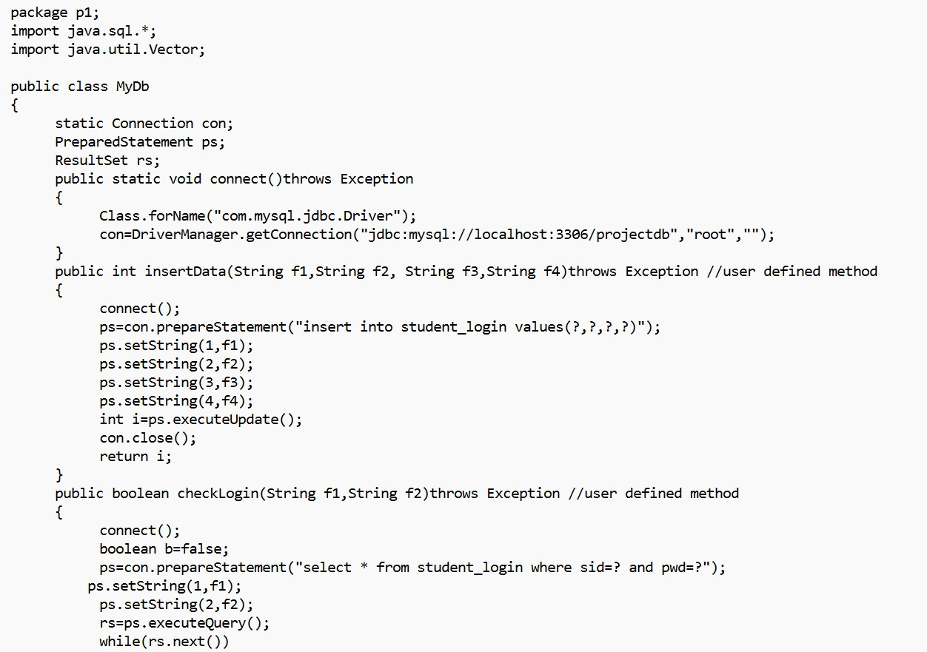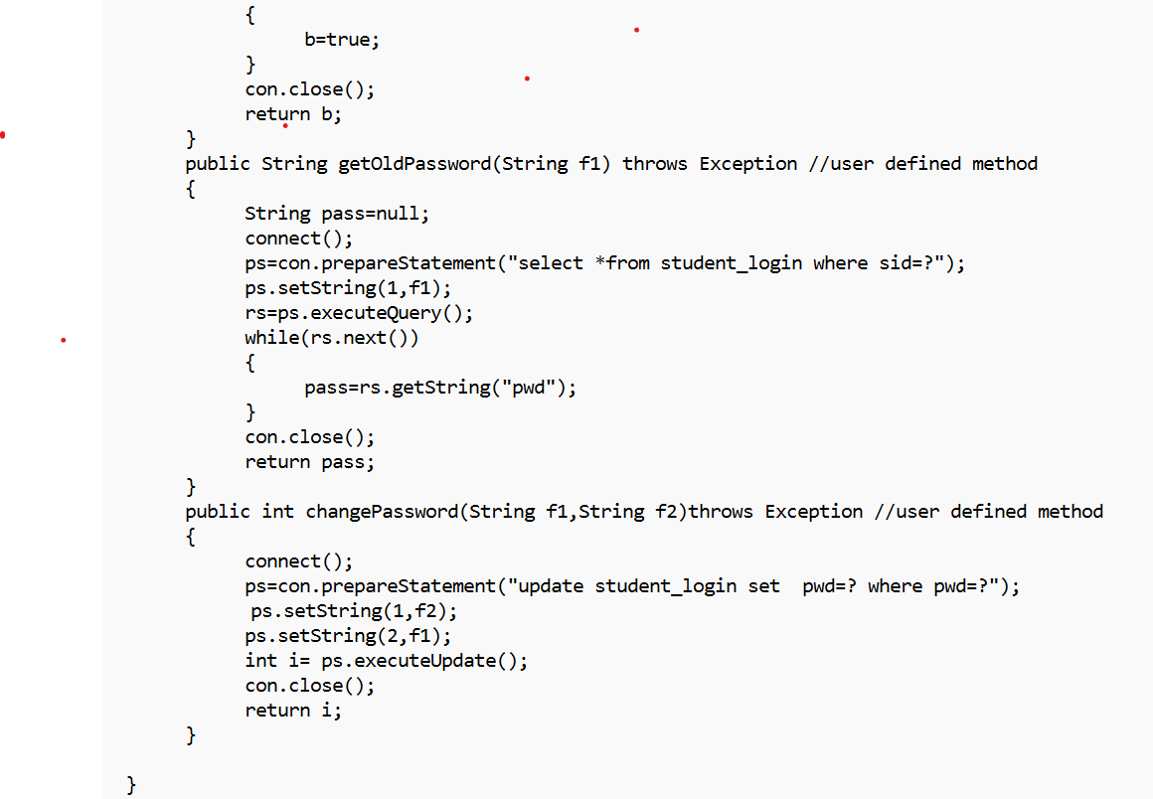

1. Code for student dashboard.

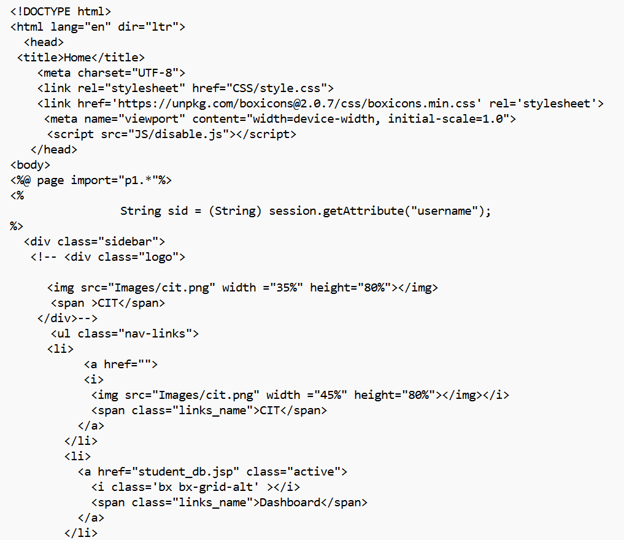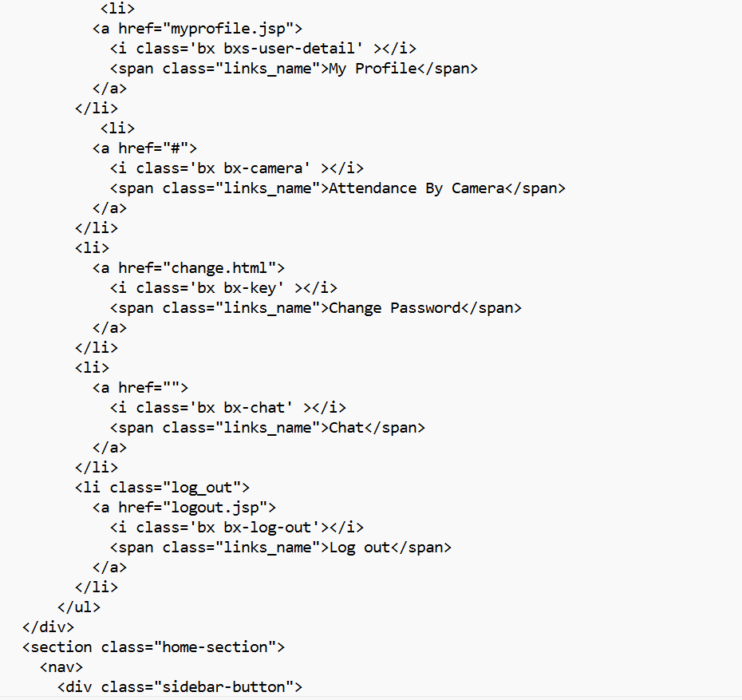

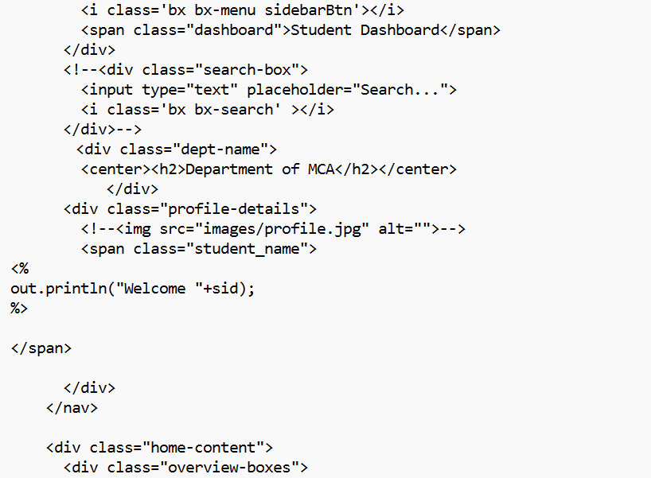

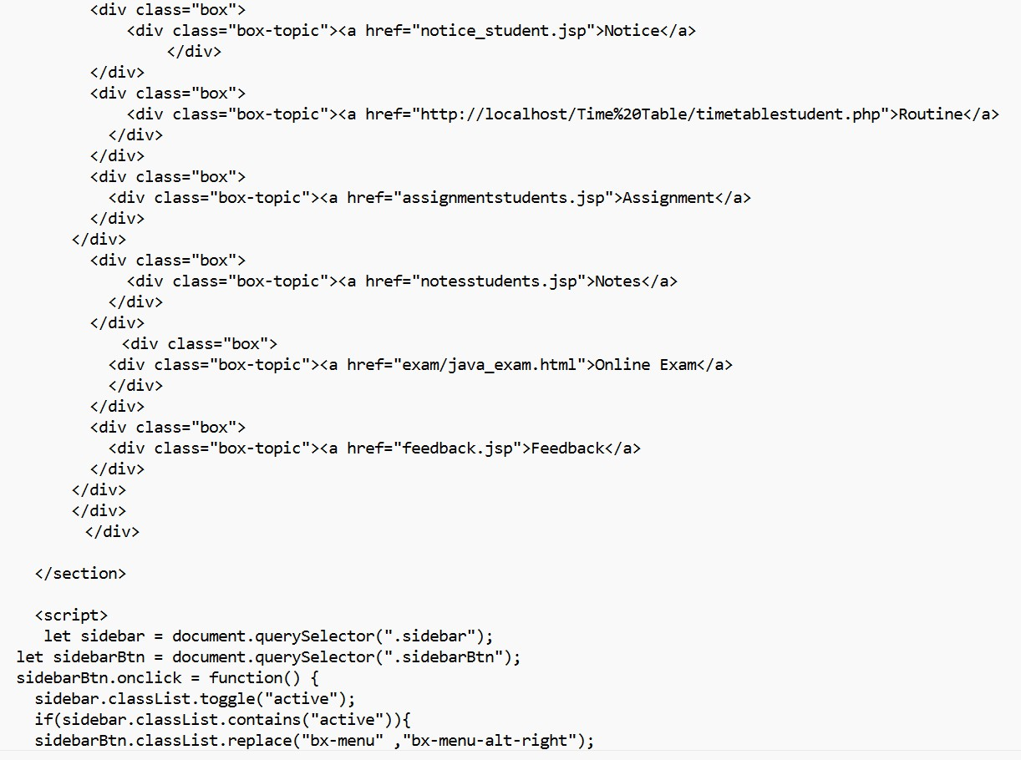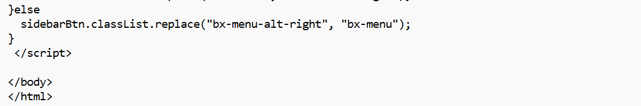

1. Code For Student Assignment

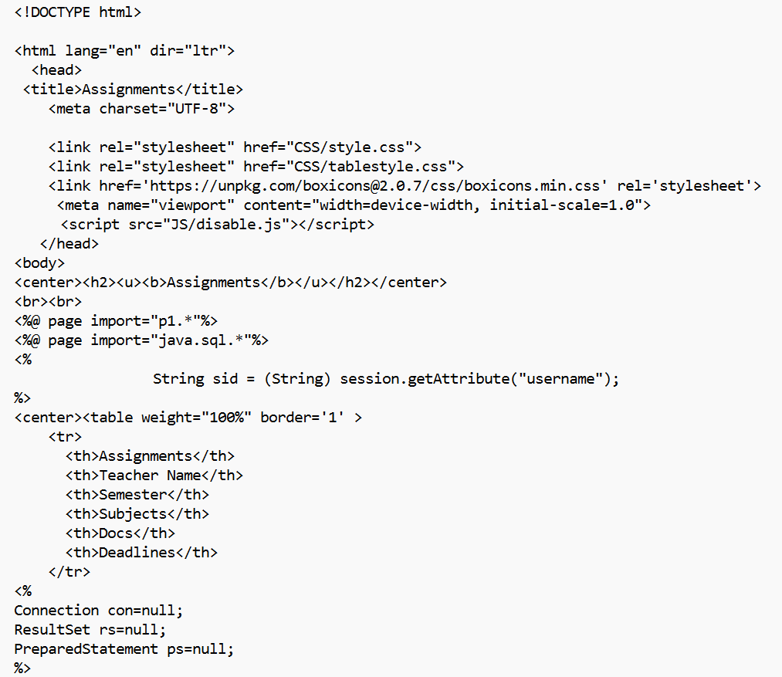

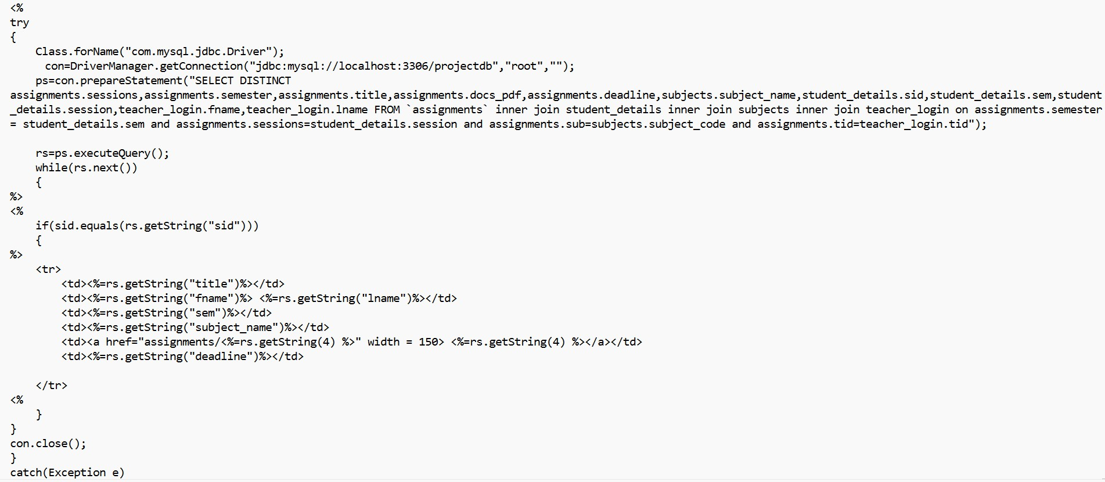

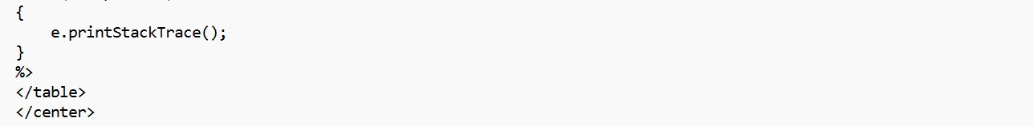

1. Code for notes page

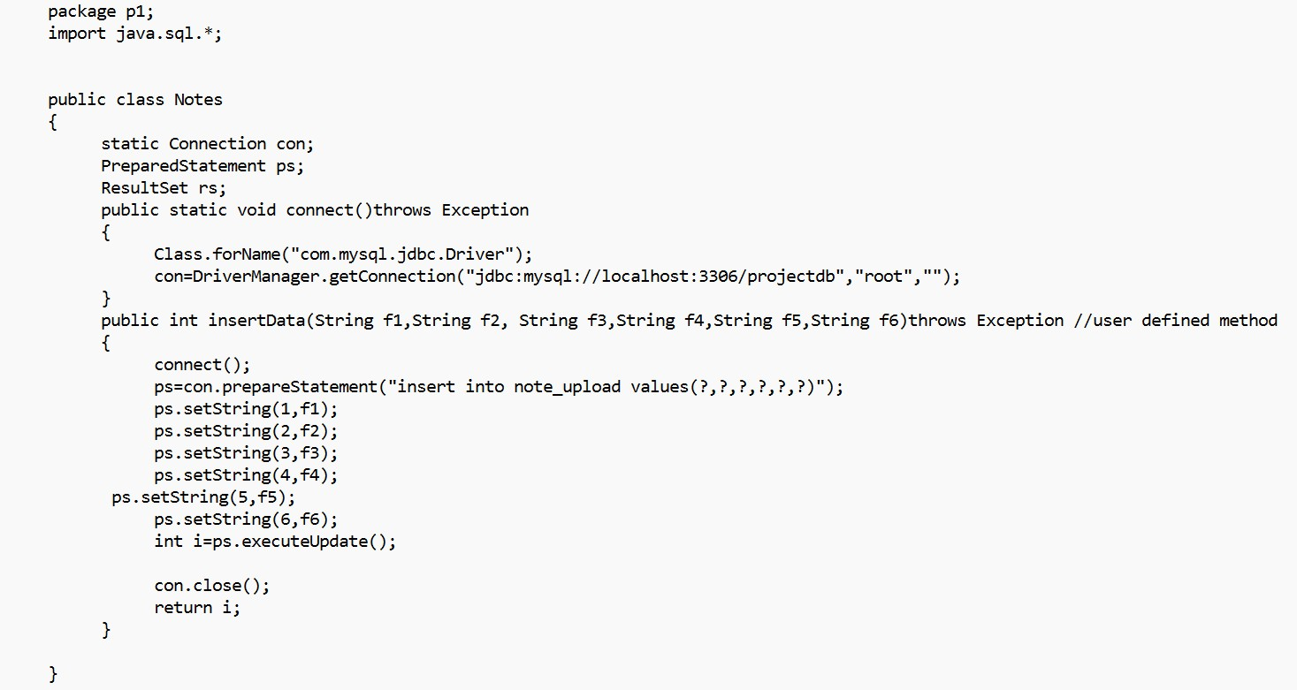

1. Displaying the notes for student

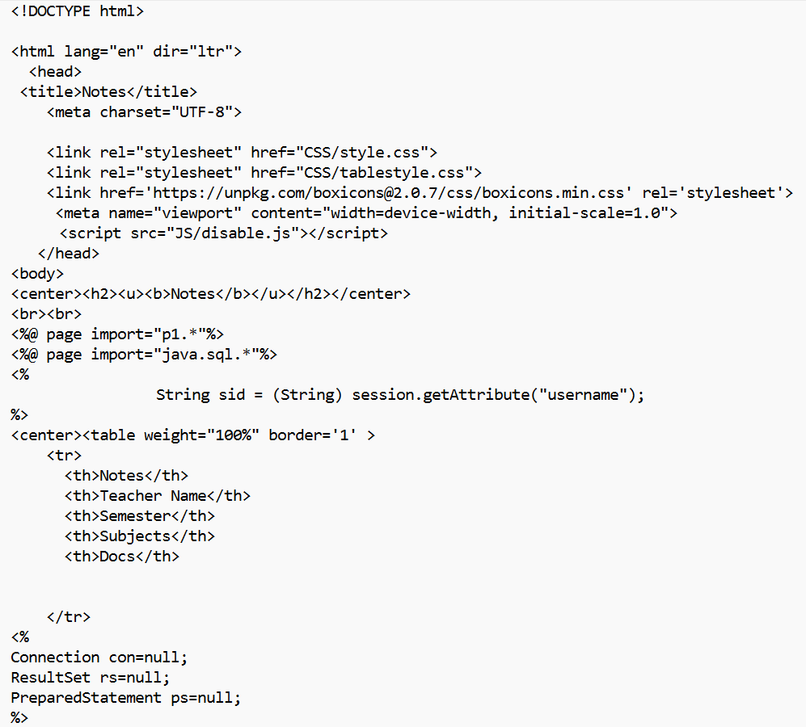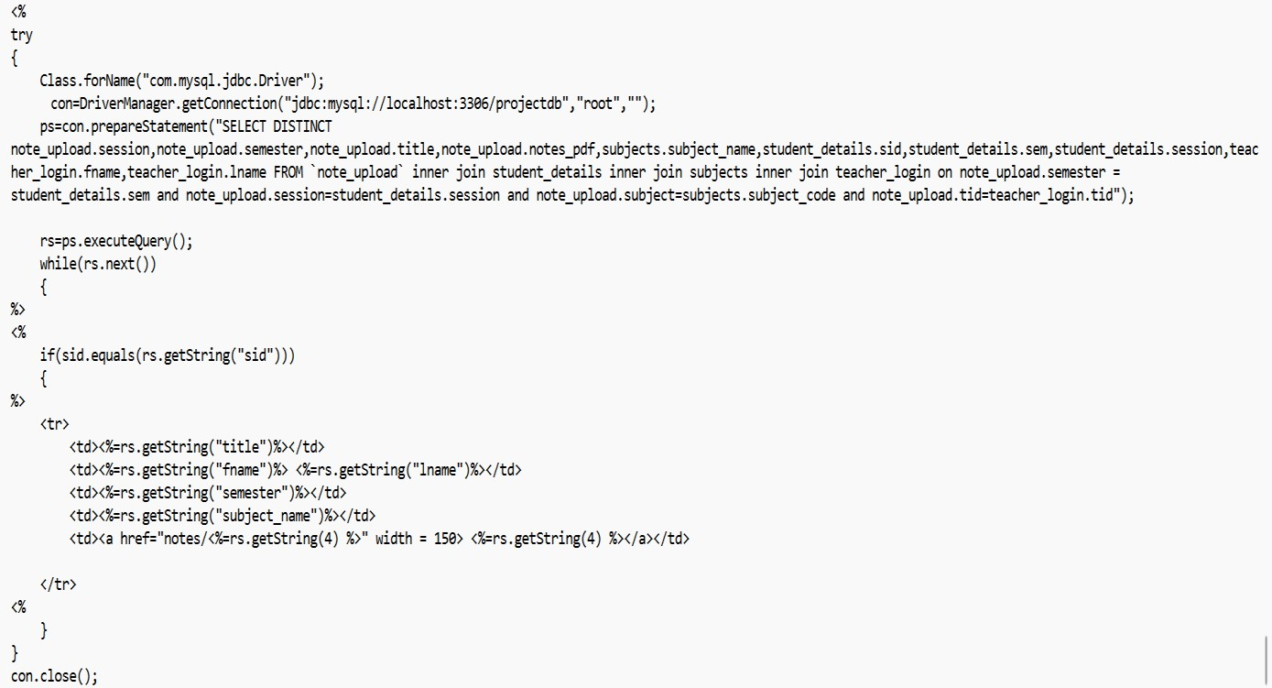

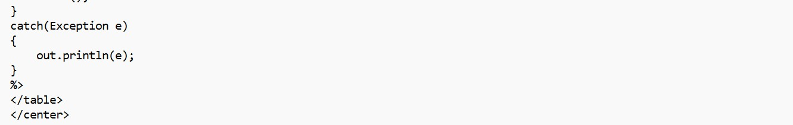

###### Upload the assignment

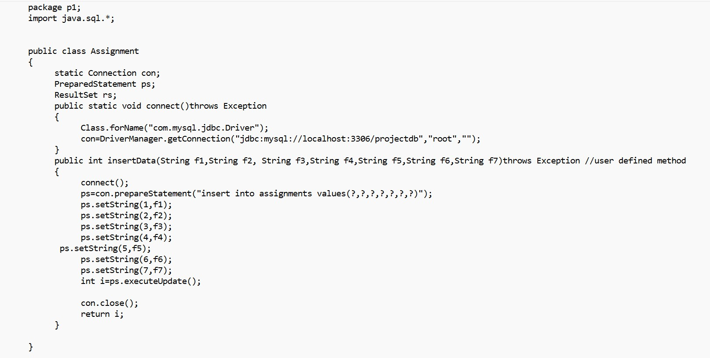

1. Code for feedback page

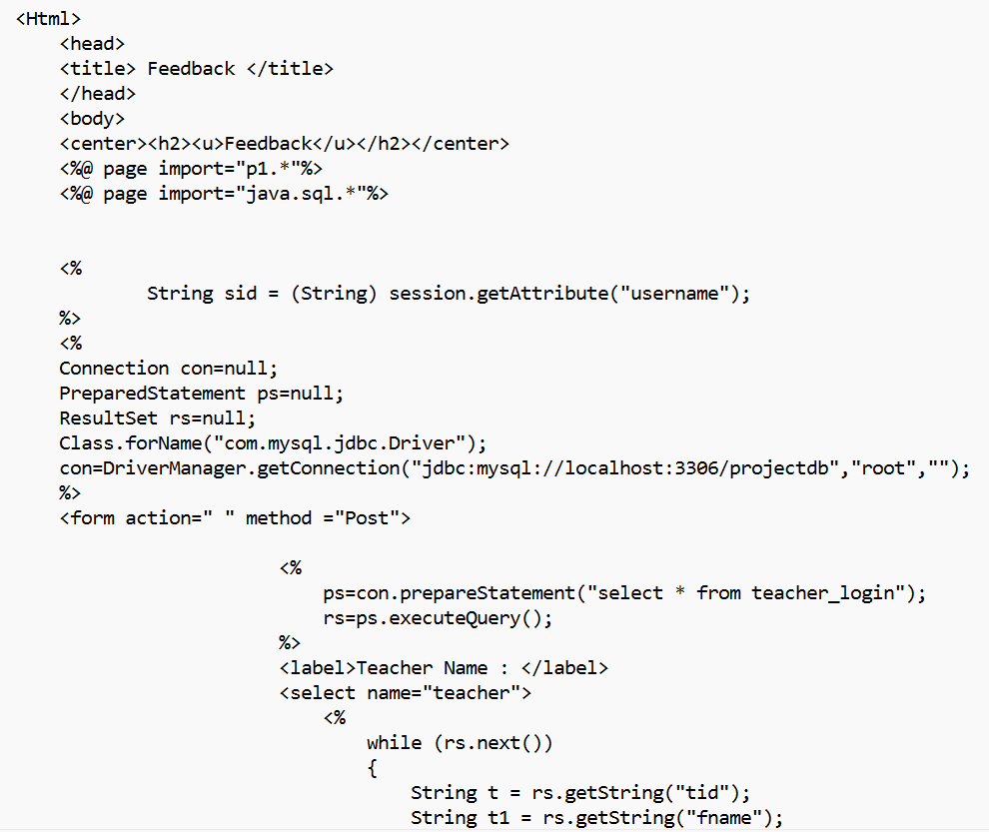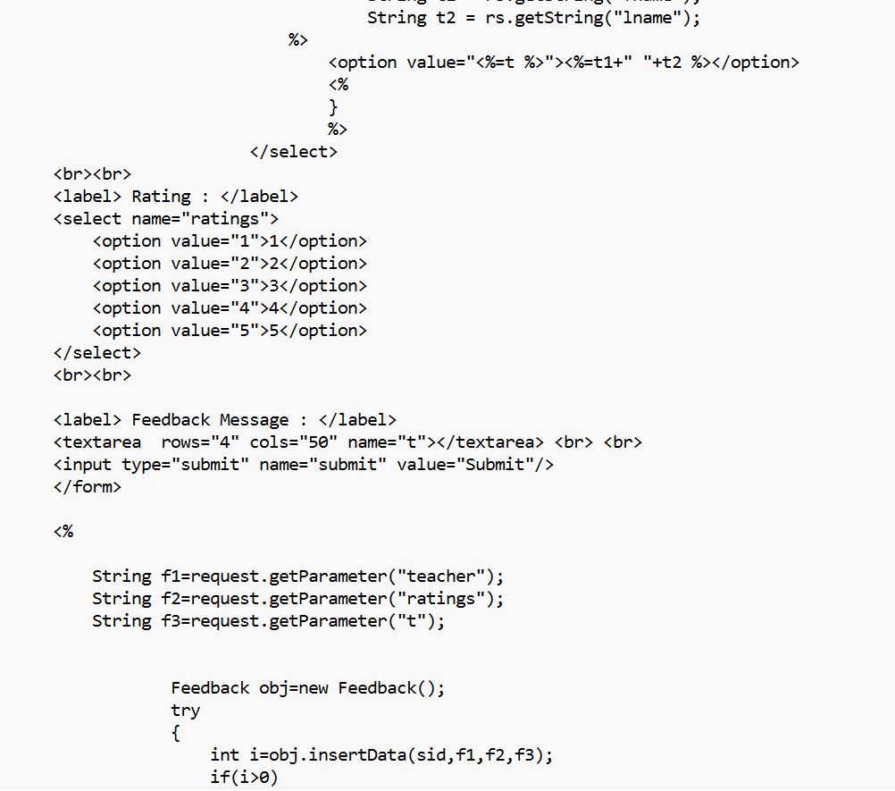

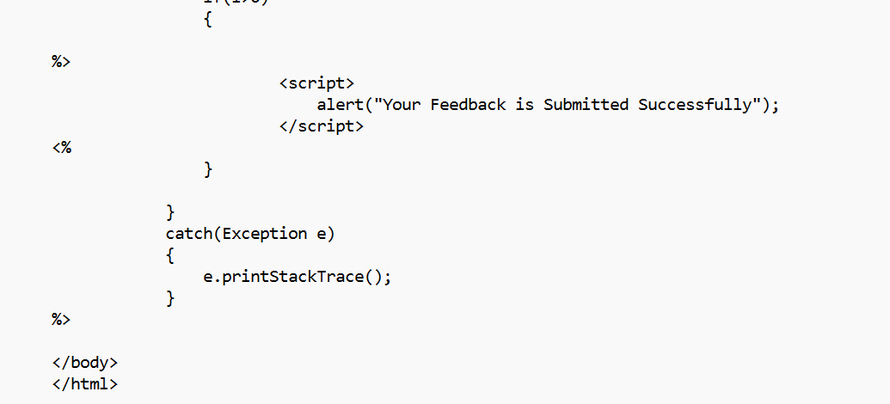

1. Code for feedback page

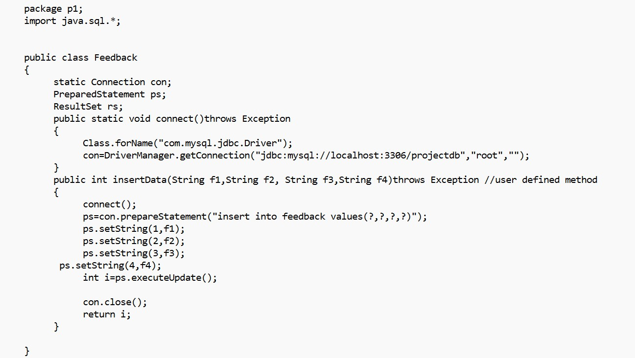

1. Code for lesion page

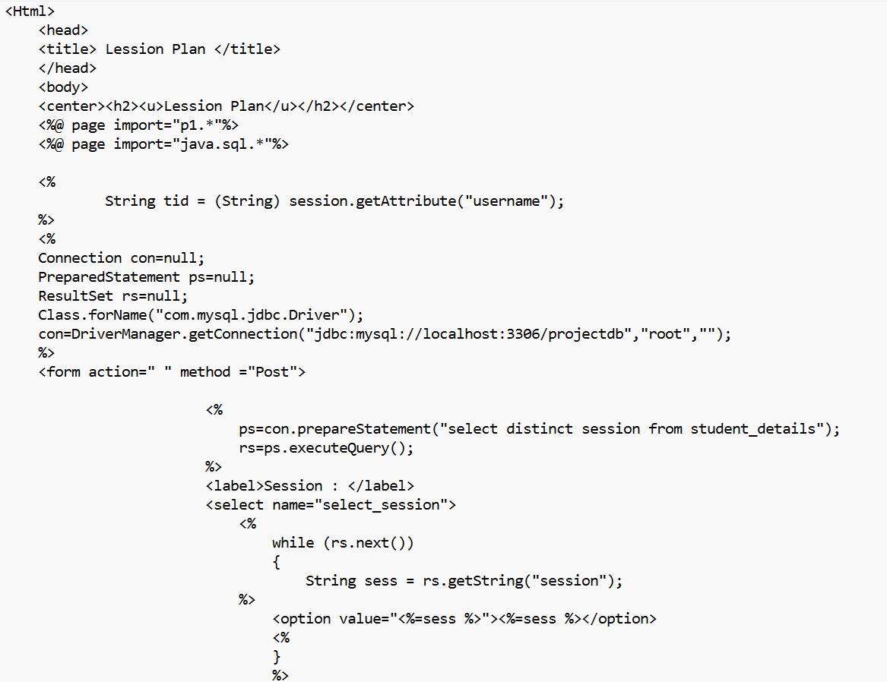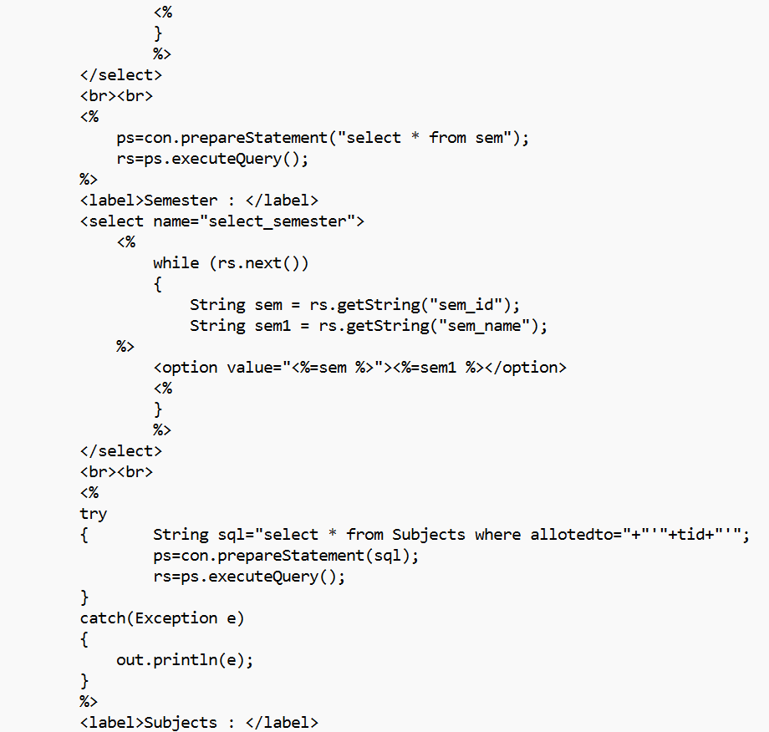

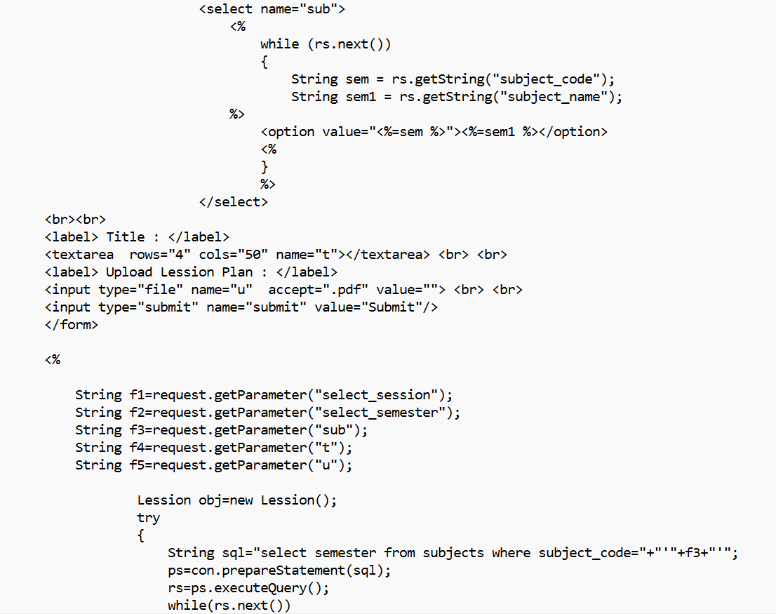

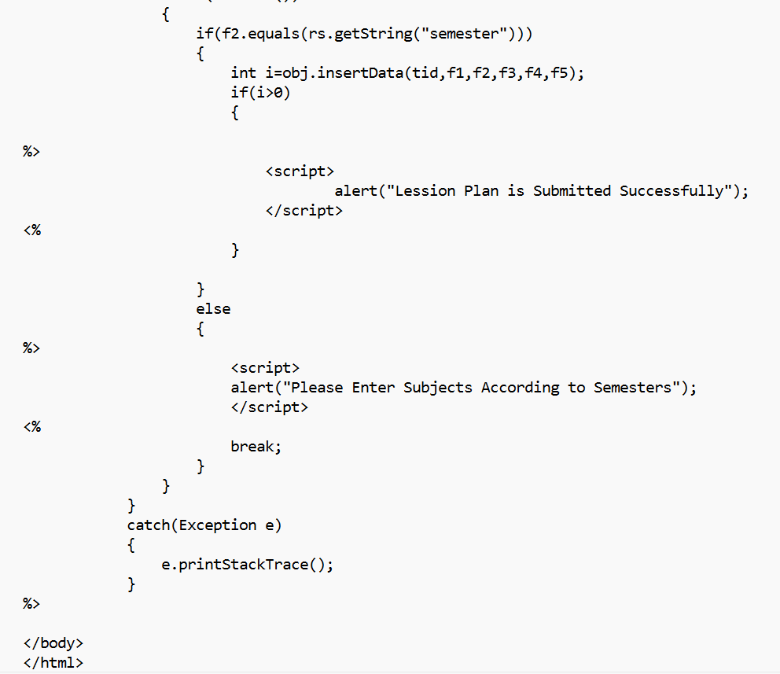

1. Code for lesion page

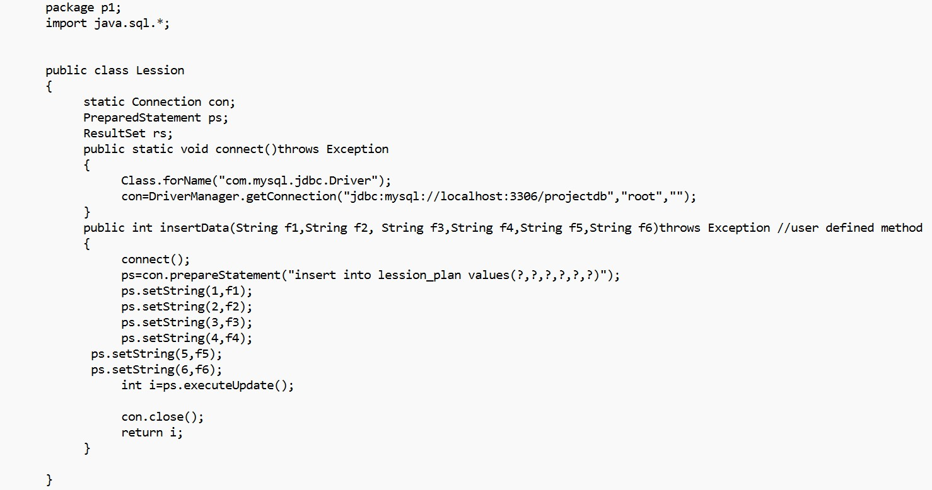

1. Code for student’s normal notice

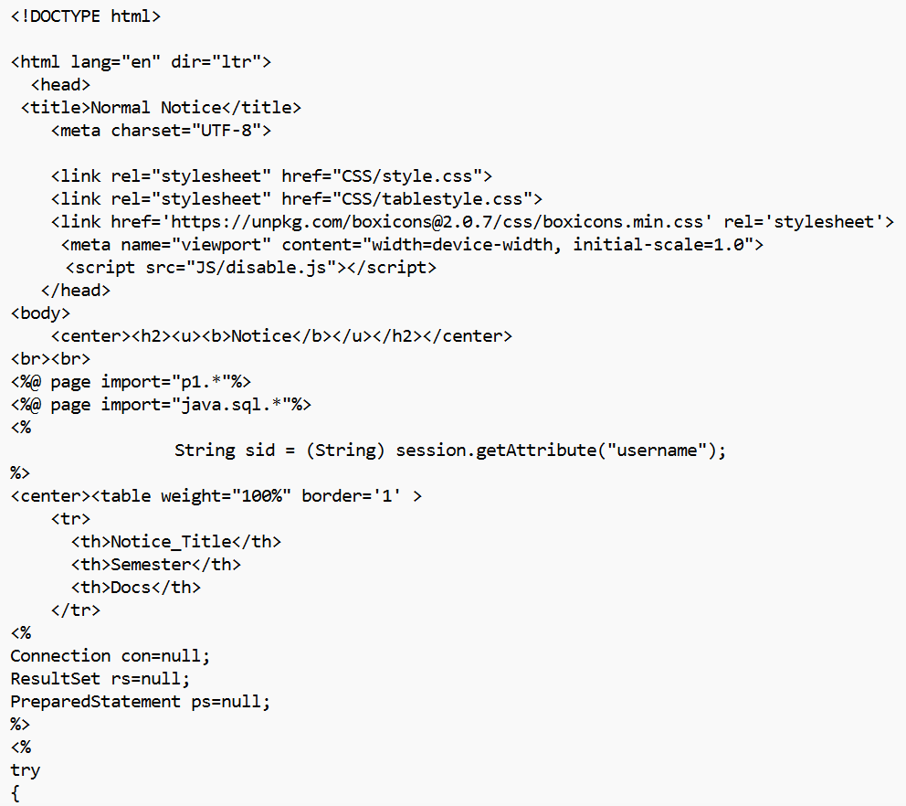

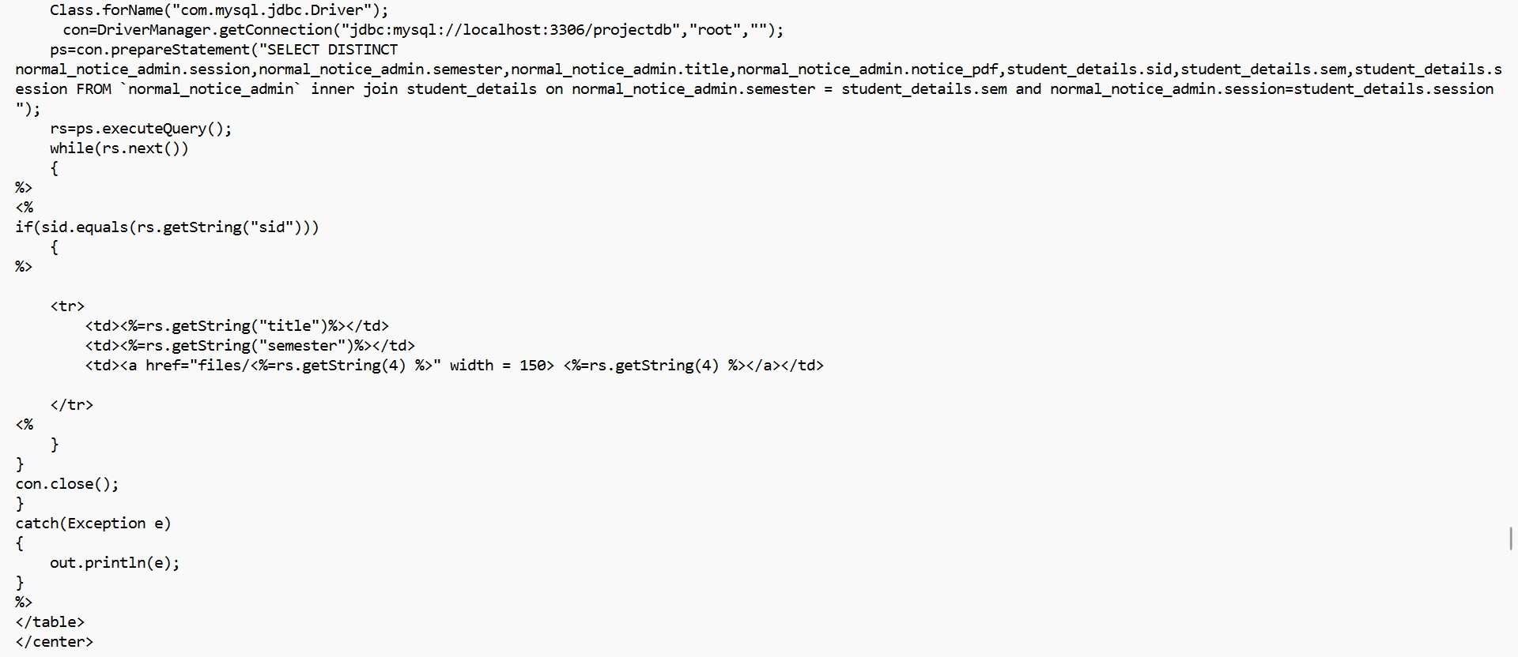

1. Code For Students Special Notice

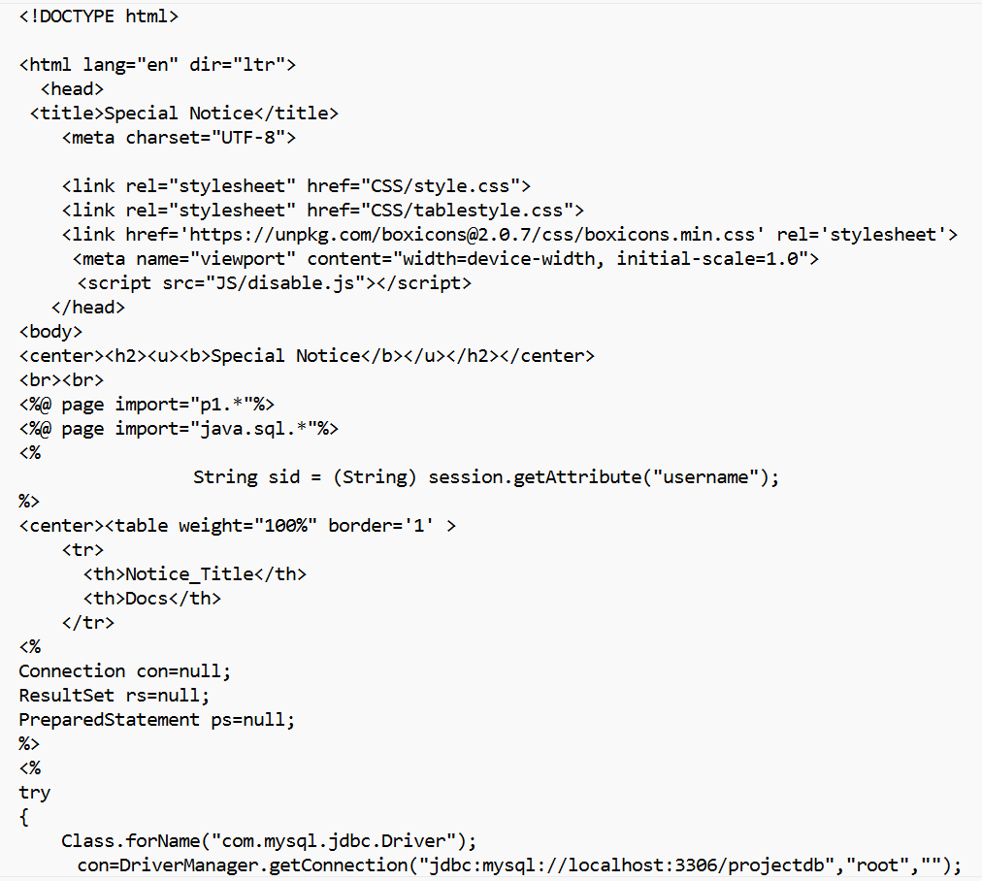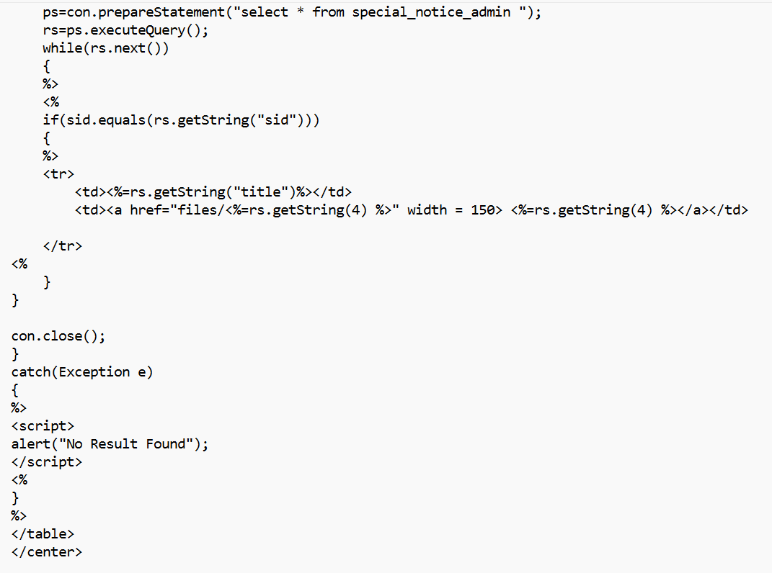

1. Code for student’s profile

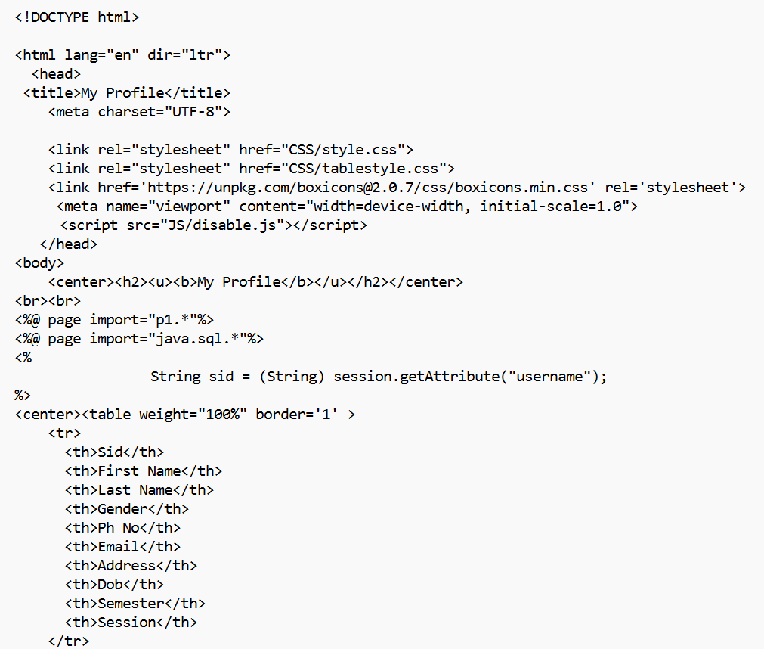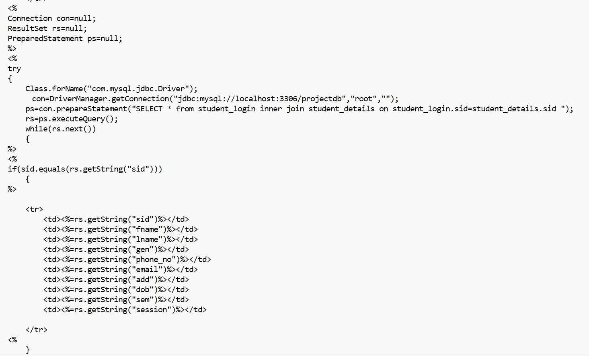

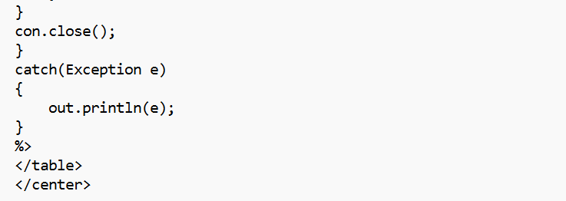

1. Code for batch creation by admin

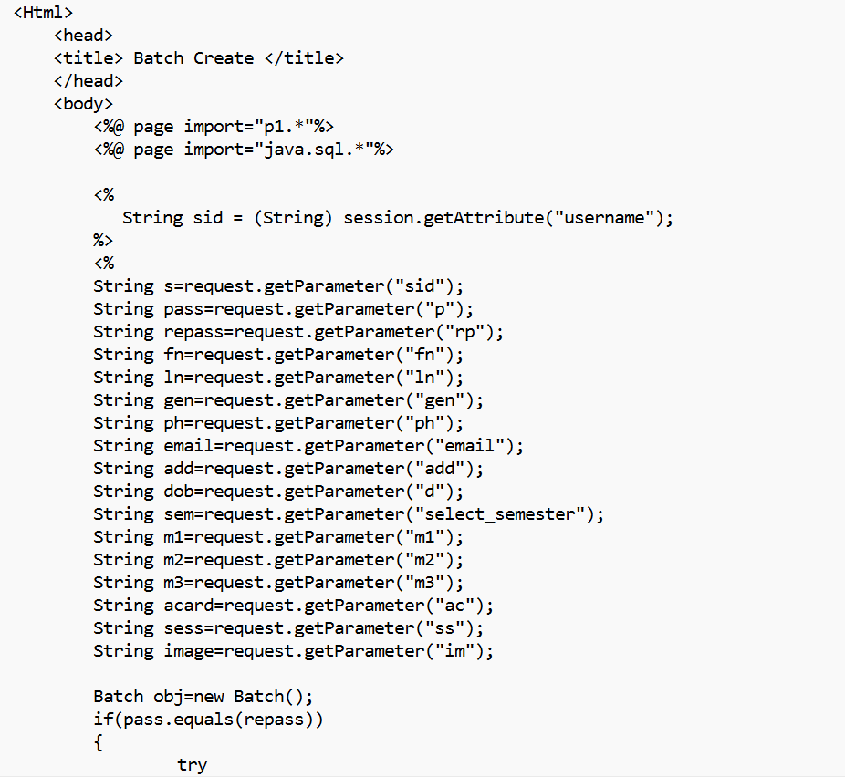

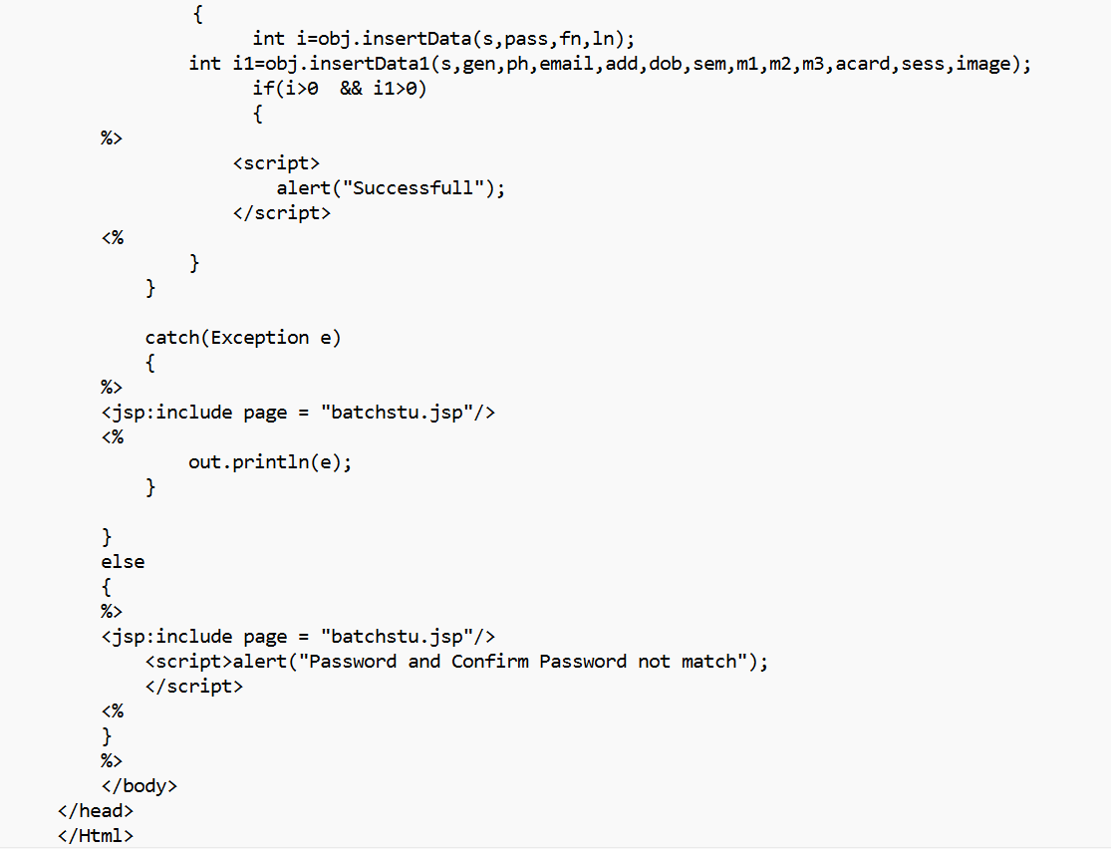

# LIMITATION

At present this system is only website based and do not have any such software for communication purpose.

It does not include information like how many computers are working within a lab or the defective ones.

Using the free express edition of SQL Server can limit how large your database files can be. SOL Server Standard edition has an upper limit of 524 peta bytes, but it is not free.

If database reaches the limit of SOL Server Express Version will begin to experience errors due to the inability of the database tables to accept new data.

# FUTURE SCOPE

1. Chatbot systems can be added for communication through applications.
2. Development of Android app for the website.
3. Test for placement drives can also be added which will be designed according to the company requirements. (MCQ, Short questions etc).
4. Better animations with user interface (UI).
5. Number of electronic devices (fans, lights or computer systems) in each class or lab will also be mentioned in room module.

6. Here we have no any kind of special attendance system. So at the future time we can add here special smart attendance system where student can give their attendance by themselves only.

# CONCLUSION

The overall speedup is considerably higher than the manual work. The management system enhances the functionalities of the routine works of the department in a number of ways. The computerization helps the users a lot to minimize the working time with ease. The department staffs get information in desired manner. Data retrieval is also easy and fast. This also restricts the users to enter invalid data and reduces the burden on the department. The data maintaining has been made quite simple.

# BIBLIOGRAPHY

* 1. CoreJAVA,TanweerAlam,KhannaPublishingHouse.
  2. Professional Java Server Programming- J2EE 1.3 Edition- SubrahmanyamAllamarajuandCedricBuest-Apresspublication,2007.
  3. Core JavaServer Faces-Second Edition-David Geary,CayHorstmann- PrenticeHall-2007.
  4. KartikiDatarkar, April 2016, Online college management system,InternationalJournalofComputerScienceand Mobile Computing, IJCSMC,Volume 5, Issue no.4,April2016,pg.118– 122https://[www.ijcsmc.com/docs/papers/April2016/V5I4201657.pdf](http://www.ijcsmc.com/docs/papers/April2016/V5I4201657.pdf)
  5. Jigar Makhija, 0ctober 2015, IICT Department Mnagement websitehttps://[www.slideshare.net/jigarmakhija/college-department-](http://www.slideshare.net/jigarmakhija/college-department-management-) [management-](http://www.slideshare.net/jigarmakhija/college-department-management-)*system*
  6. DEPARTMENT MANAGEMENT SYSTEM [WEB-BASED APPLICATION],June 2020,Jhanvi Agarwal, Renuka Singh, Mansi Singh, Mansi Raghav Student IMSEngineering College Ghaziabad, Indiahttps://[www.researchgate.net/publication/346208202_DEPARTMENT_M](http://www.researchgate.net/publication/346208202_DEPARTMENT_MANA) [ANA](http://www.researchgate.net/publication/346208202_DEPARTMENT_MANA) GEMENT_SYSTEM_-_WEB-BASED_APPLICATION.
  7. OmkareTiware,March2018,CollegeActivity Managementsystem,InternationalResearchJournalof Engineering and Technology, Volume05Issue03https://[www.irjet.net/archives/V5/i3/IRJET-](http://www.irjet.net/archives/V5/i3/IRJET-V5I3205.pdf) [V5I3205.pdf.](http://www.irjet.net/archives/V5/i3/IRJET-V5I3205.pdf)
  8. ArchanaR.,June2016,ANEWPRACTICAL APPROACH OF MANAGEMENTSYSTEM, International Journal of Engineering Applied Sciences andTechnology, Vol. 1, Issue 7, ISSN No. 2455-2143, Pages 79- 82[http://www.ijeast.com/papers/79-82,Tesma107,IJEAST.pdf](http://www.ijeast.com/papers/79-82%2CTesma107%2CIJEAST.pdf)